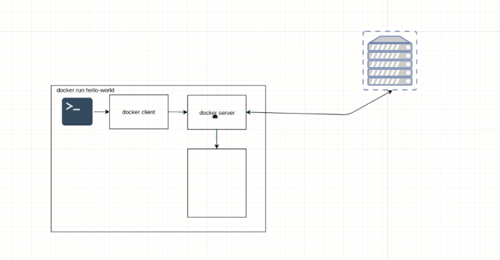

Terminal – invokes the Docker client

Docker Server – is the demon that runs behind, the Docker server checks the local image repository and if the image is not found, sends a pull Rest Request to Docker Hub. When you make a pull request for latest updated image only the delta will be downloaded.

**Port Mapping:**

Port generic concepts…

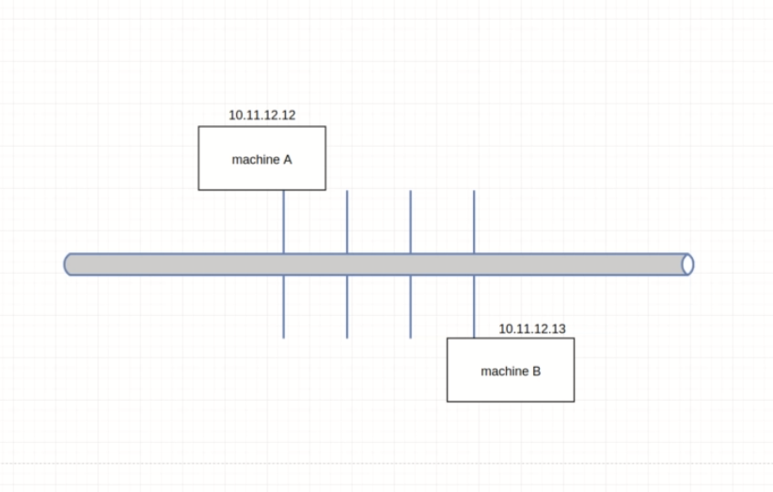

To connect to you machine B which runs any service we need either the IP address or the Host name. Once the machine is identified , we need to access each application via a unique Port Number as the application are running in the same host . Else if you want the same port to be used , the current application has to be stopped sending info on the port and the othere application has to send

IP Address – to identify the machine among n number of machines

Port No – to identify the application within the machine

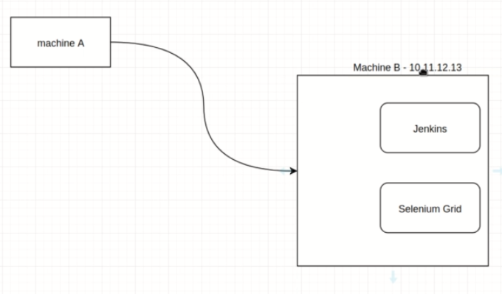

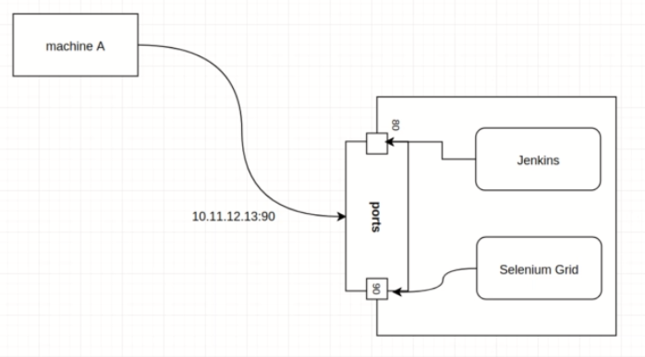

Assuming Docker , has different container running different servers. Here each containers are different VM which behaves as an indepndent machine(hosts), So the same port can be used across the application.

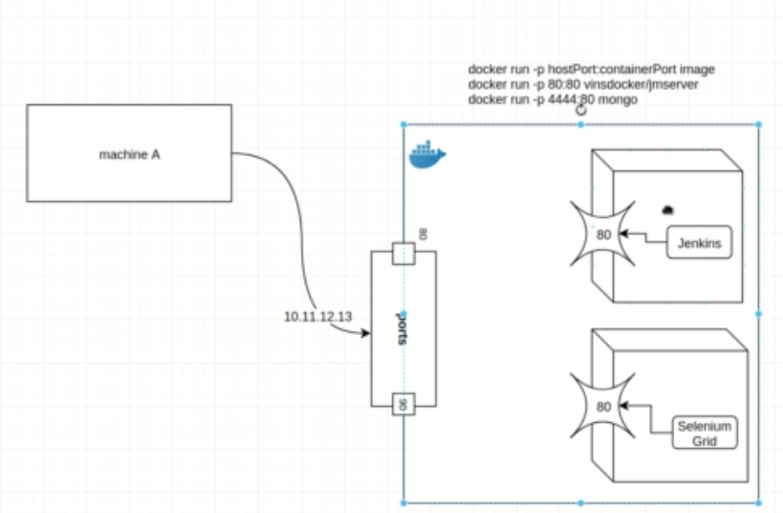

The client machine cant use a single port to listen to both the application. In this case we need to map the host ports to unique client ports such that they can list to each applications . **This is called PORT Mapping**

If machine wants to access Jenkins, need to access the host machine with the IP and listen to Port 80

Docker run –p hostport:containerPort image

-p for Port Mapping . For Jenkins as given below

Docker run –p 80:8050 vinsdocker/jenkins

80 is the default port , if machine A gives the host number it would interact with Jenkins as 80 is default port and it is mapped to Jenkins and if he specifies 90 he will be connected to Selenuim Grid

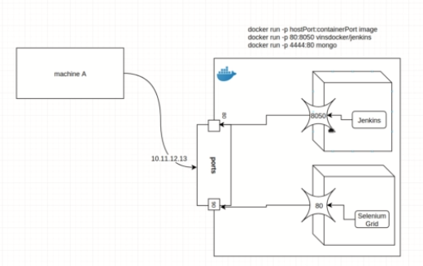

**Port Mapping Demo:**

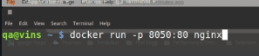

Here Nginx did not exit, as this is a websever and will be running. Now to connect to nginx I will connect with the local host to port no 8050

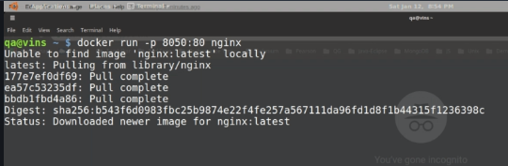

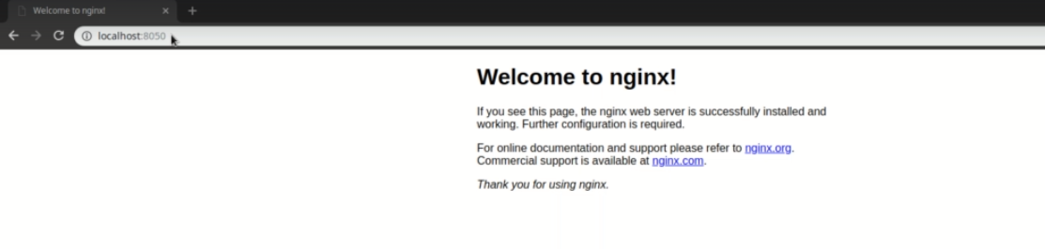

Docker says some info when the application is accessed from local host. Press control+c to exit from the sever. The server would be stopped

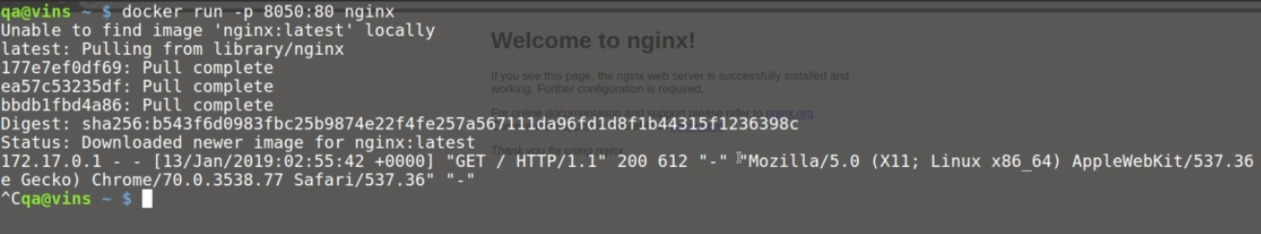

Check the browser for the local host. As the container is killed

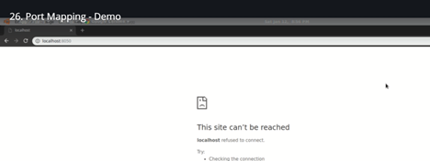

Run the image again



The server would be running



Clear all the unused container



When any machine connected to me as host, sends and listens to port 8040 will be directed to port 80 of the VM that is nginx.

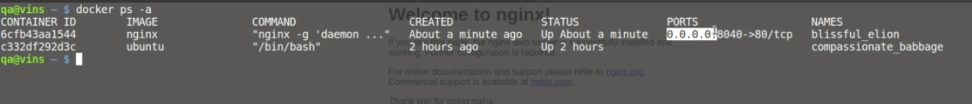

Docker Stop Command

**‘docker system prune –f**

Clears all the unused containers

**‘docker system prune –a**

Clear all unused containers and images

**‘docker ps –a**

Displays all the containers

‘**docker stop container-name | docker stop container-id**

Will stop the container. Type the name and press tab will auto fill

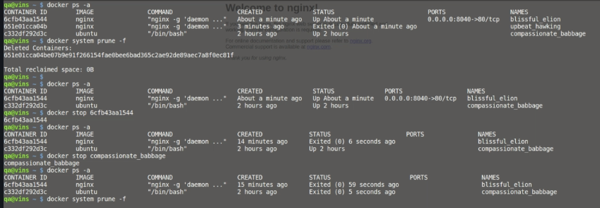

**‘docker run –d –p 8050:80 ngnix’**

Run the image in the background (-d) and do port mapping

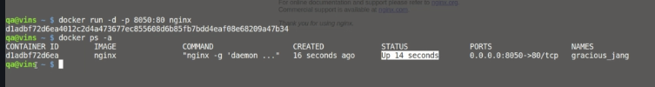

**Docker Volume Mapping:**

When you run your tests in a container, all the files and results that are produced would be saved in the container. We cannot view it from the host machine. To enable viewing it we need to perform a volume mapping that is we need to create a folder in our local machine and map it to the folder in the container. That way any files created in the container will be created in the host and any files created in host will be viewable in the container. When the container is stopped the files in the host will not be deleted and would be retained

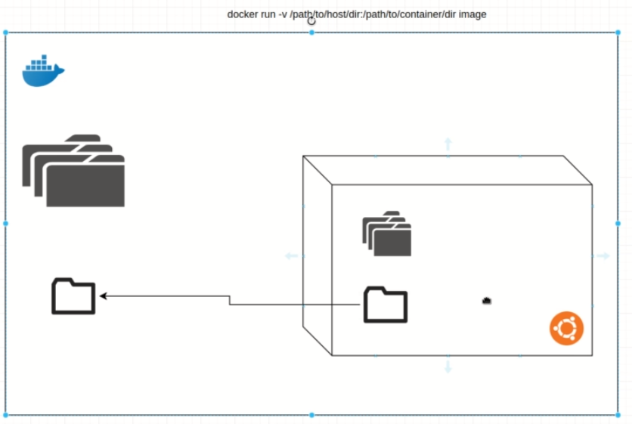

**Demo:**

Check the parent-working directory of the host machine and get the dir. Now ls-all to see how many folders are there. There are no folders.

‘docker run –it – v /home/qa/workspace/udemy-docker:/a/b/c ubuntu

If the /a/b/c folder tree is not available in ubuntu , the docker will create the folder structure. Always give a path like home or usr etc. The command above creates ubuntu in interactive mode

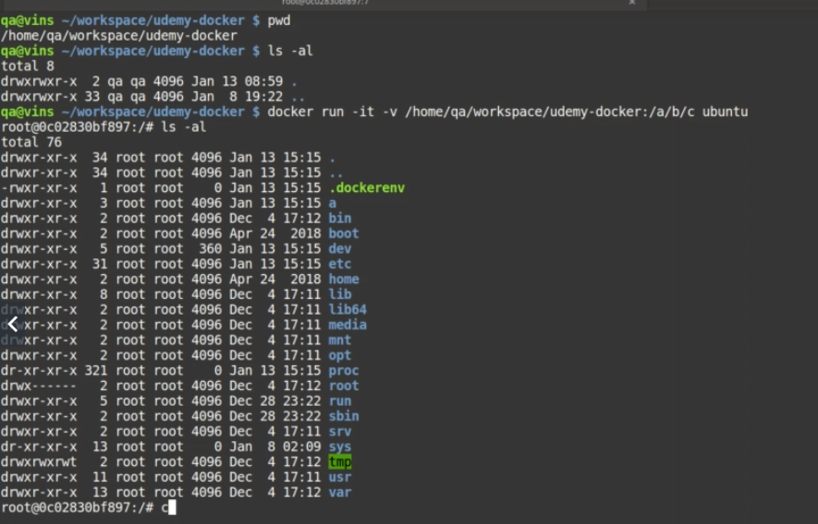

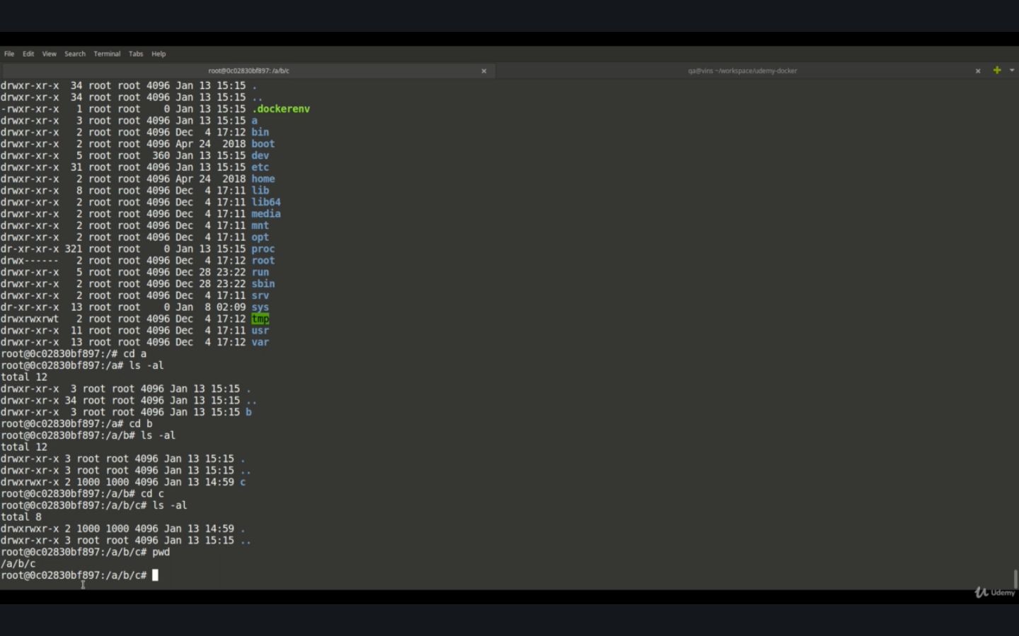

The folder a is created no change directory to a (cd a) . Repeat the procedure ls –al to list all folders and change directory to b and to c. Now list all the folders there wont be any files created. Now open cmd in new window and type pwd. In the parent directory you wont fine any files

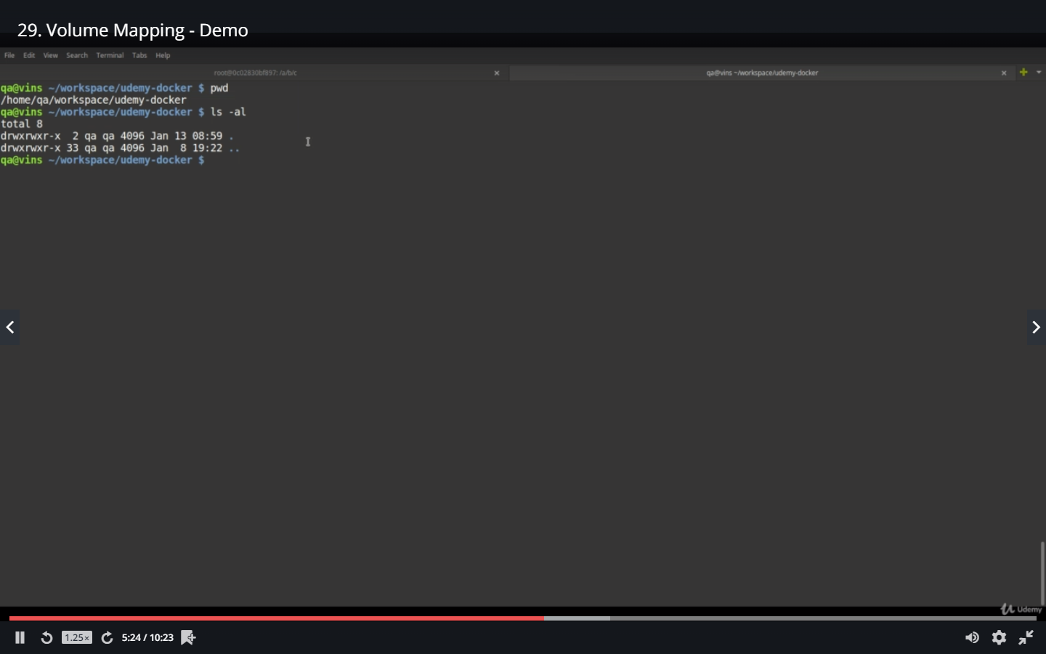

Create a file using the linux command

‘**echo “Docker is awesome” > test_resuls.txt**

Rename the file- **mv test_resuls.txt test_results.txt**

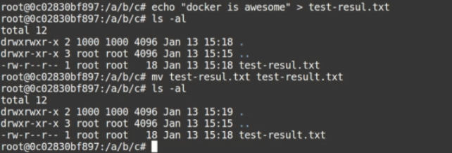

Check the host machine

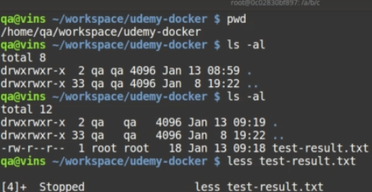

Create a directory in the host machine and see if the same is available in the container.

‘mkdir newdir-dir

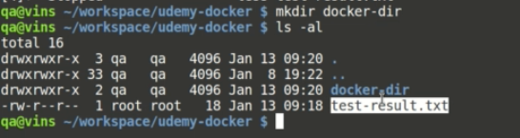

Check the same in Ubuntu container

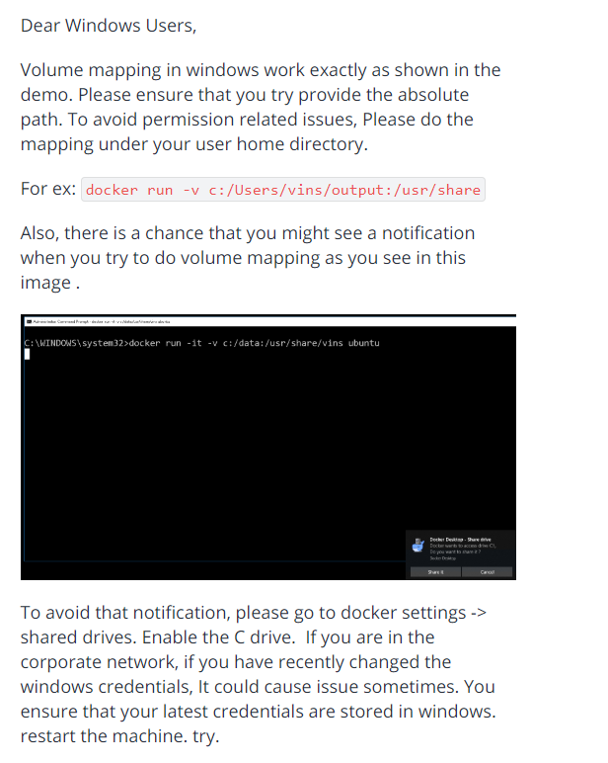

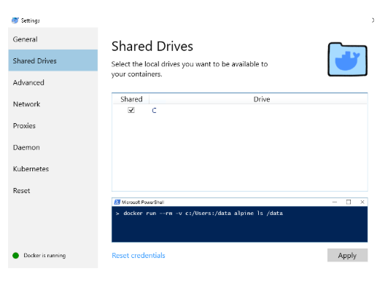

**Docker Network:**

If we have more than one containers and want the containers to interact with each other. What we need to do is create a docker network and create the containers within the network

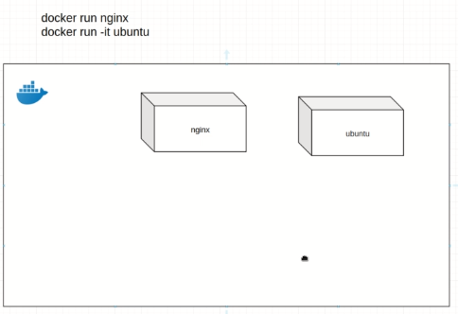

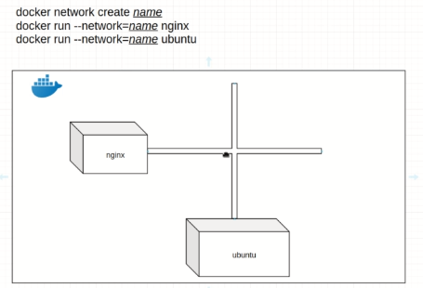

Demo:

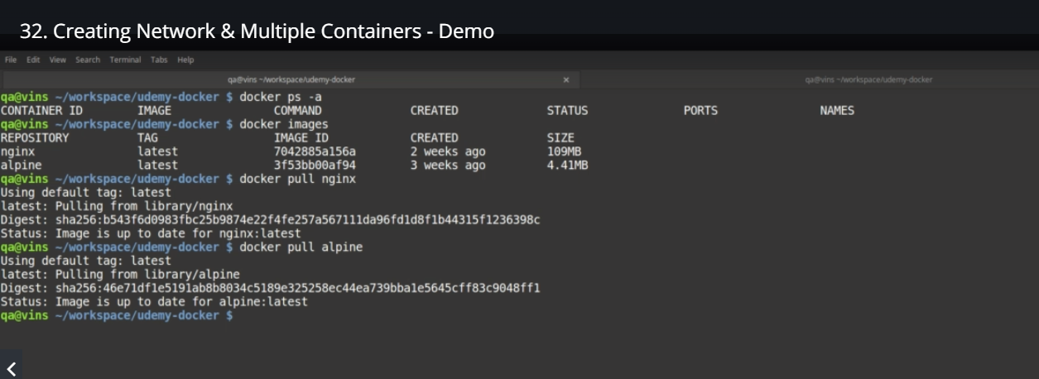

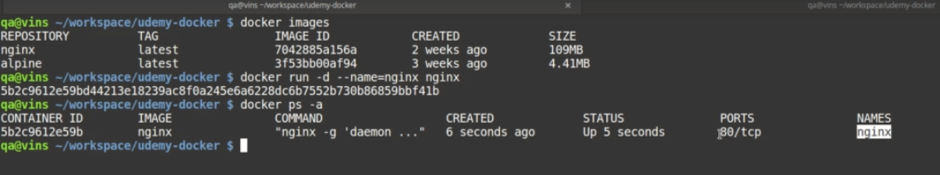

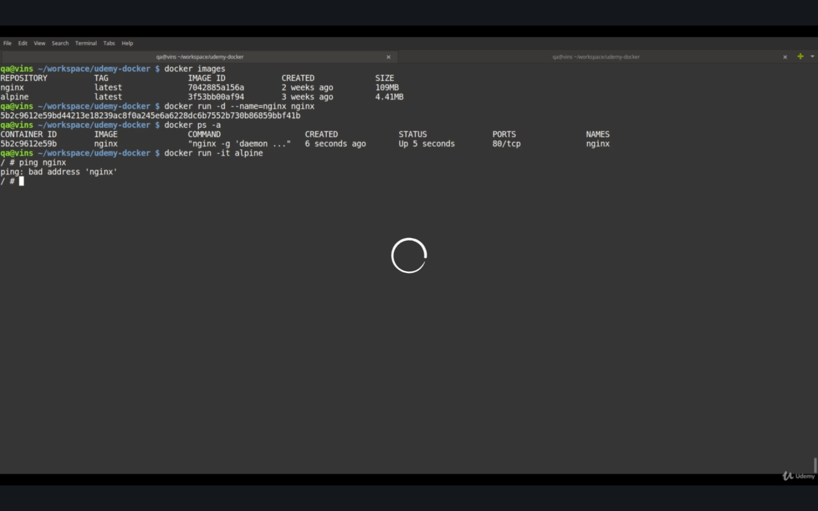

Exit from aphine and stop nginx and create a network and add nginx to the network and alphine as well

**Stop nginx**

**‘docker network create name=training-newtork**

**‘docker run –d --name=nginx -- newtork=training-network nginx**

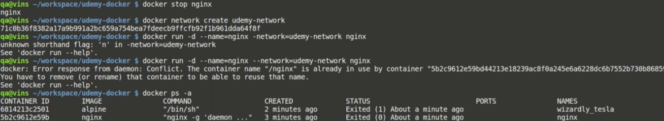

Now the nginx container that we have created is already there we cant create a new container with the same name. ‘**docker rm nginx**

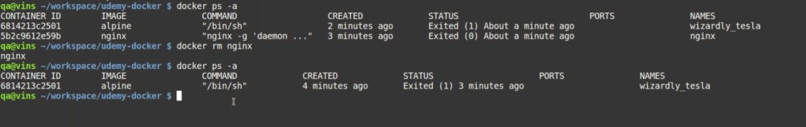

Add both the images to the network and run and ping nginx from alphine. Alhone her is created in interactive mode

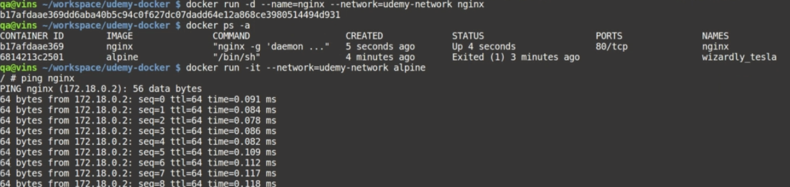control +c to exit. Now we are in alphine . if you use ‘**wget nginx**

Nginx – is the host name of the container . now we need to type the host name in the browser.

GNU **Wget** (or just **Wget**, formerly Geturl, also written as its package name, **wget**) is a computer program that retrieves content from web servers. It is part of the GNU Project. Its name derives from World Wide Web and get. It supports downloading via HTTP, HTTPS, and FTP. Get the content from the host server nginx. Now nginx is the host name like google.com etc. Now alphine has downloaded the index.html file



Read the file **less index.html**

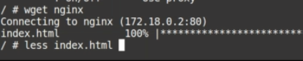

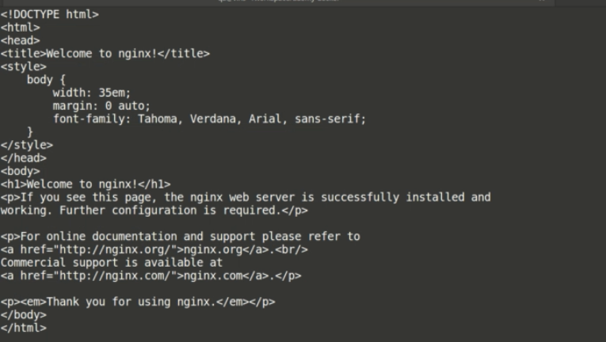

**Creating Image:**

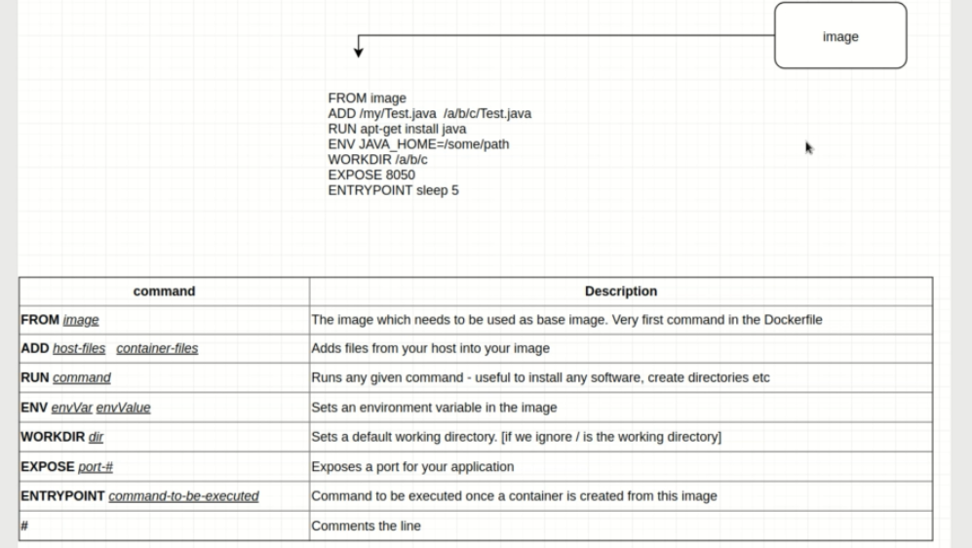

**Creating our own image**

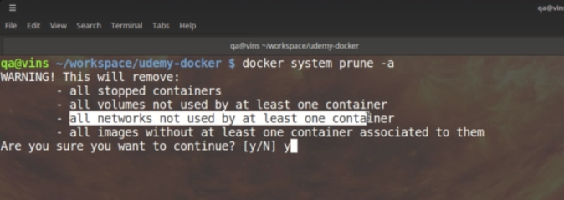

All volumes in the image will be removed but not the host files mapped to an image folder .

We are using Alpine because it has utilities like ping, wget app installer etc

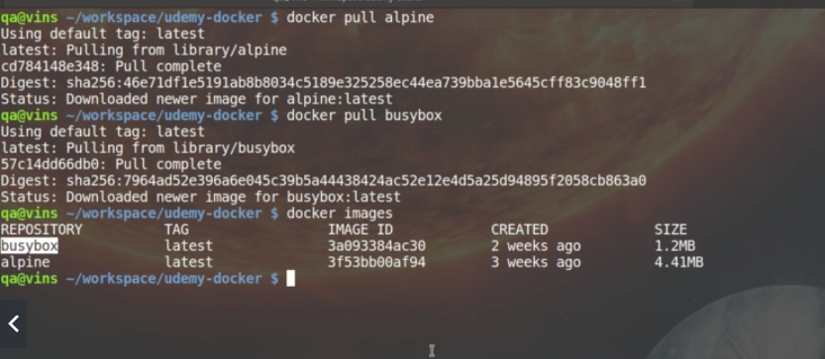

Now we are going to create a docker file. Use sublime editor Preference->PackageControl -> Type Docker Syntax hightlighter

1.Create a docker file

2. Create an image

3 . Push to Docker hub

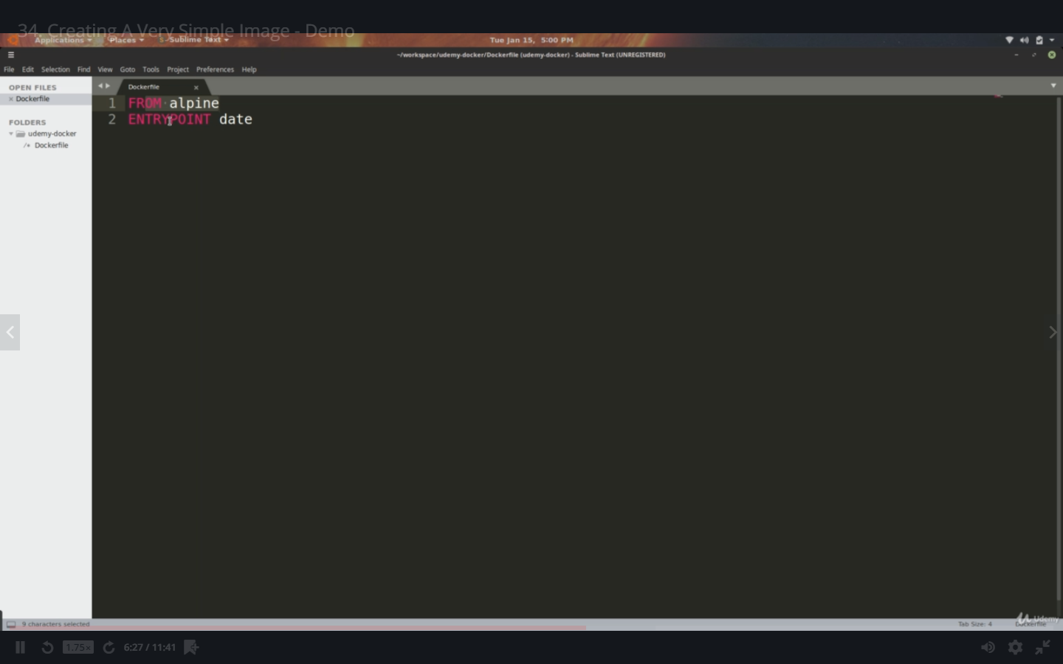

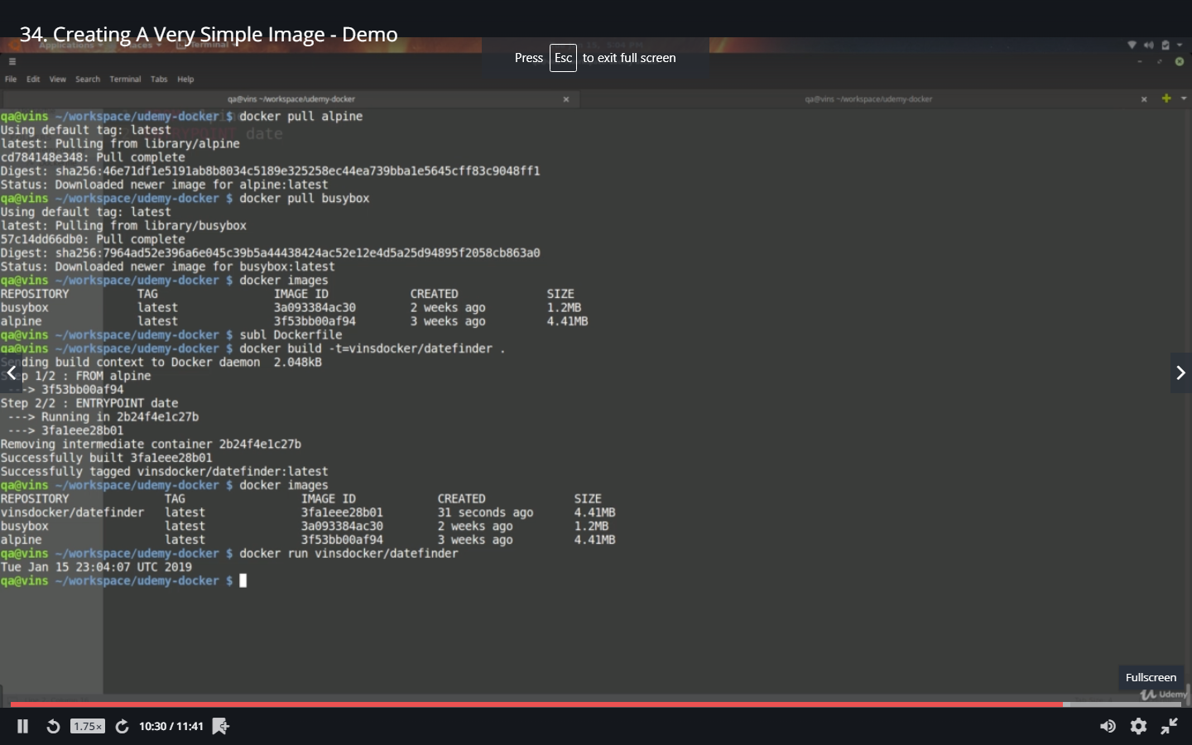

‘**docker build –t=subsdocker/datefinder .**

‘. Represents the current directory. It has searched for the docker file, have created, and image for it

Create a Java Program and place in the docker file and create an image and run it from the container.

Run Alphine in interactive mode. List all folders in the root directory ‘**ls –al**

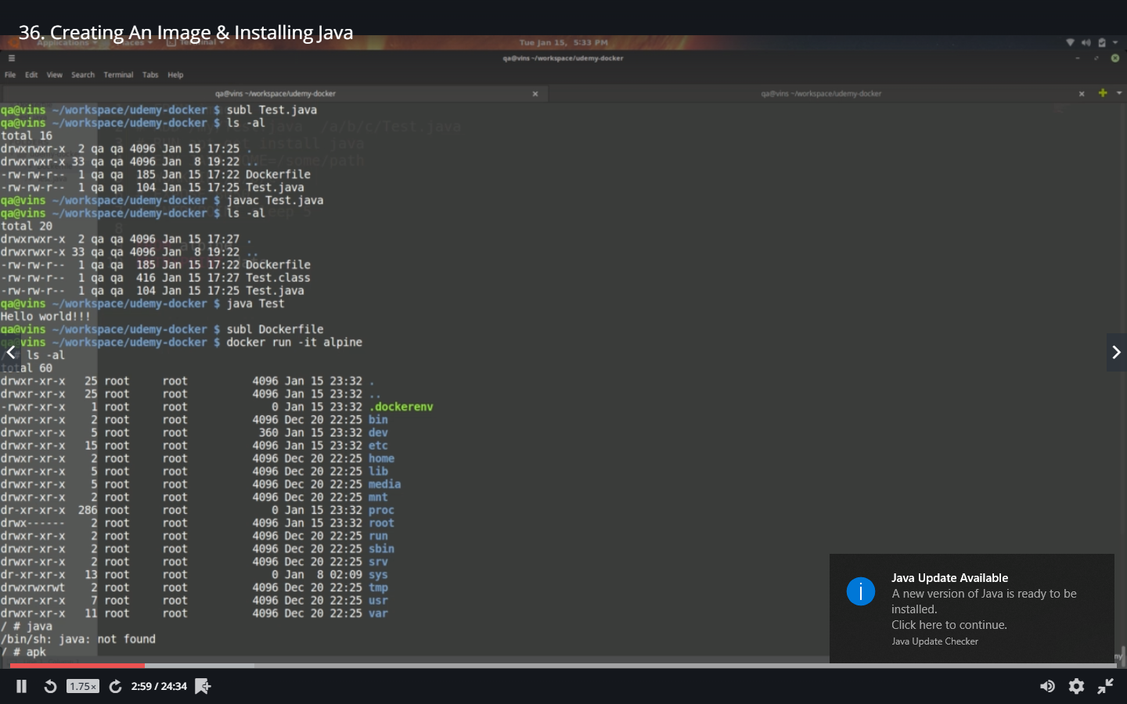

Java not found. Alpine has package installer “apk”. Press enter it lists all commands available

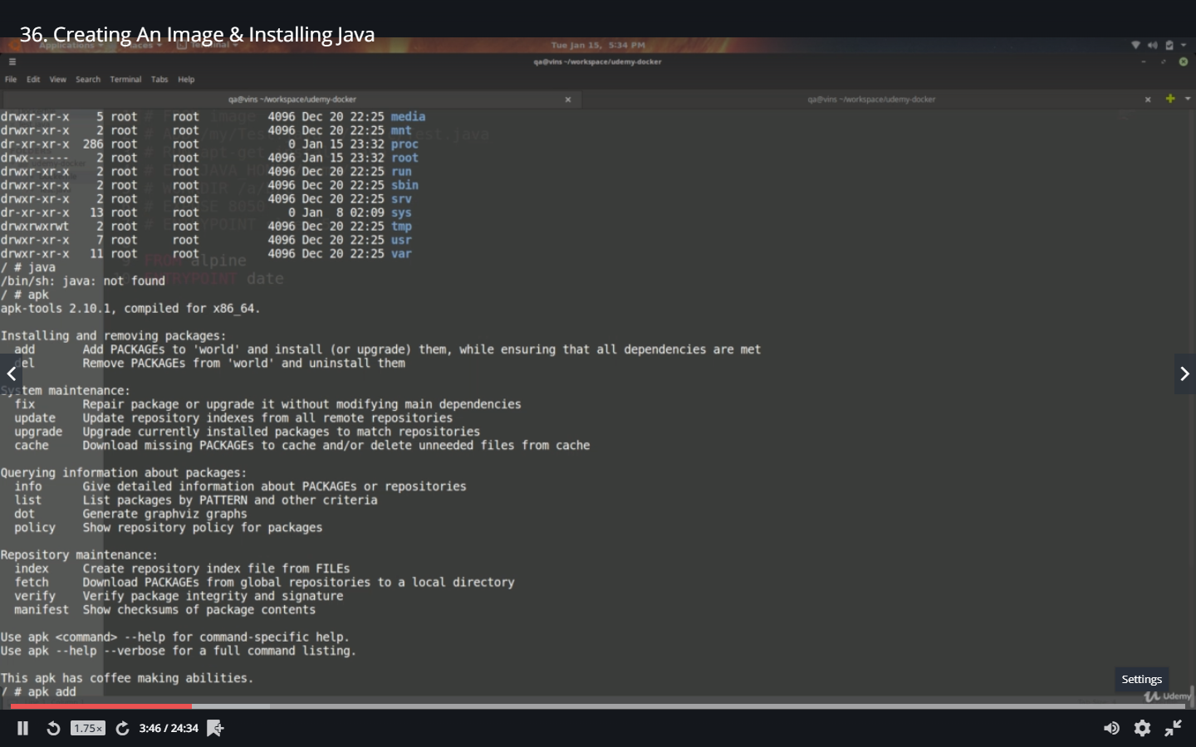

‘apk add openjdk8

OpneJDK is the base jdk for java.

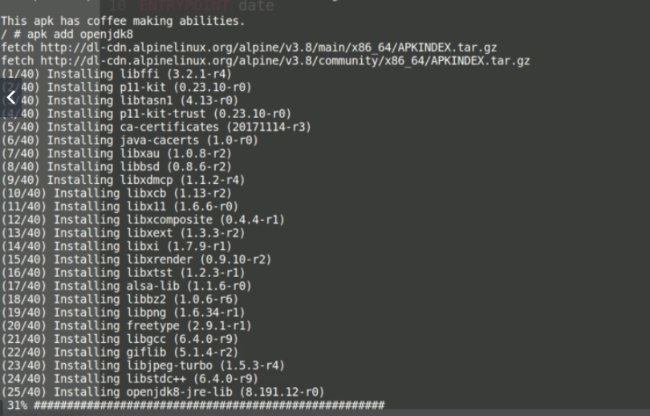

Tried searching for javac and not found . checked for java its found. Just type find command to list all the files in the directory. This being the root directory all the files will be displayed

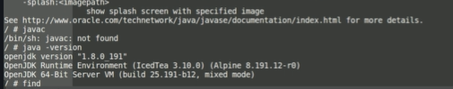

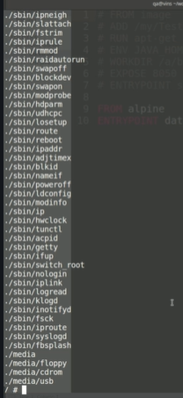

Java C tool to compile the java program



Copy the path where javac is located and add this to the system Path using **“:”**

**Echo $PATH**  will print the PATH location

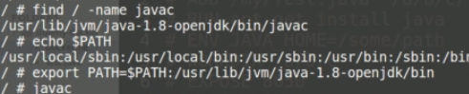

See each path is appended with **“:”**

Now append javac path to $PATH using export cmd

‘**export PATH= $PATH:/usr/lib/jvm/java-1.8-opejdk/bin/javac**

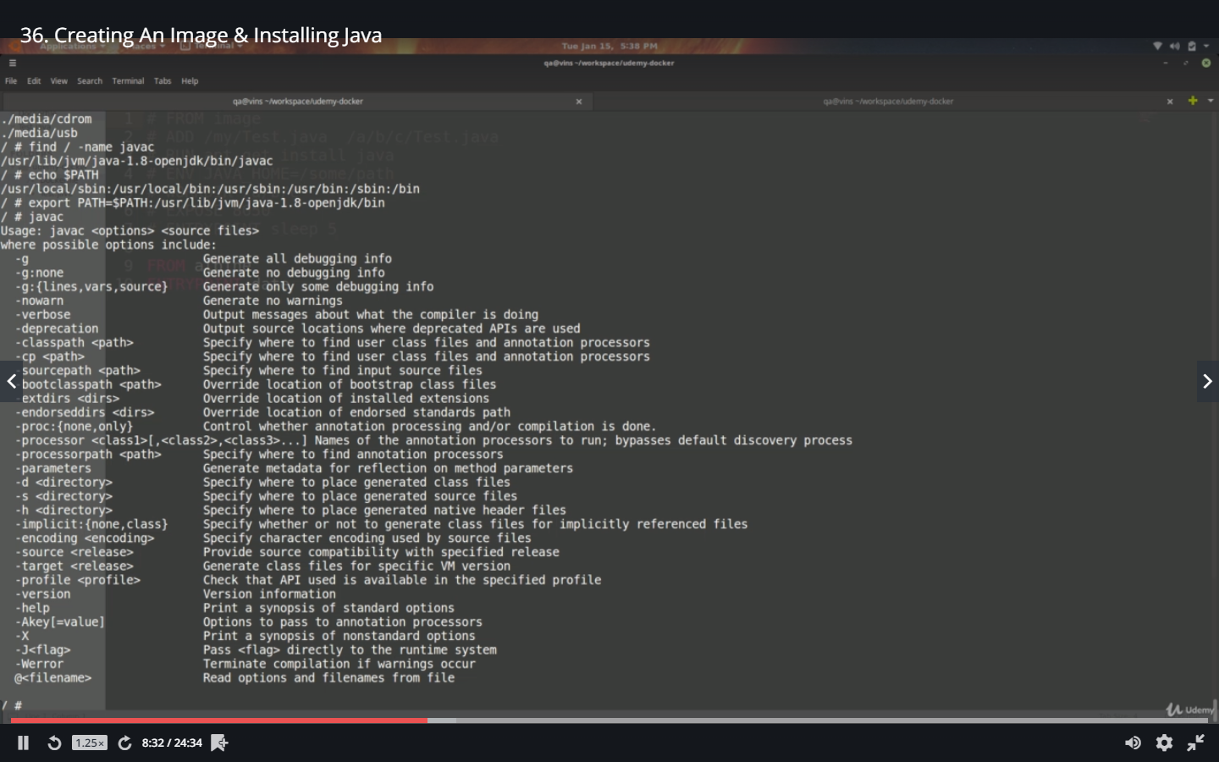

Check the list of directorys in the root and c possible location where you can place your java file.

**‘ls-al**

**‘cd usr**

**‘ls-al**

**‘cd share**

**‘mkdir training**

**‘ls-al**

**‘cd training**

**‘pwd**

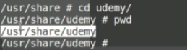

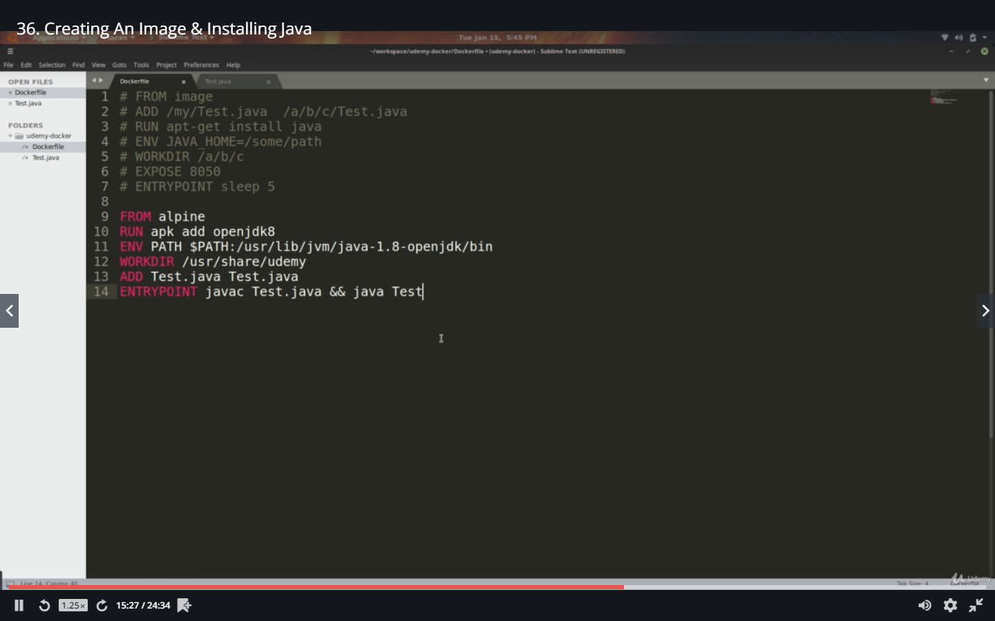

**From Alphine** *– we are using the alpine image as the base*

**RUN apk add openjdk8** *–use package installer apk and install java 8*

**ENV PATH $PATH:/usr/lib/jvm/java-1.8..bin** *- add javac path to PATH*

**WORKDIR /usr/share/training** *–specify the working directory*

**ADD Test.java Test.java** *– add Test.java from the current directory where the docker file is and place it in the working directory of the image. If you want to specify the absolute path do it*

**ENTRYPOINT javac Test.java && java Test** *–execute these commands one by one*

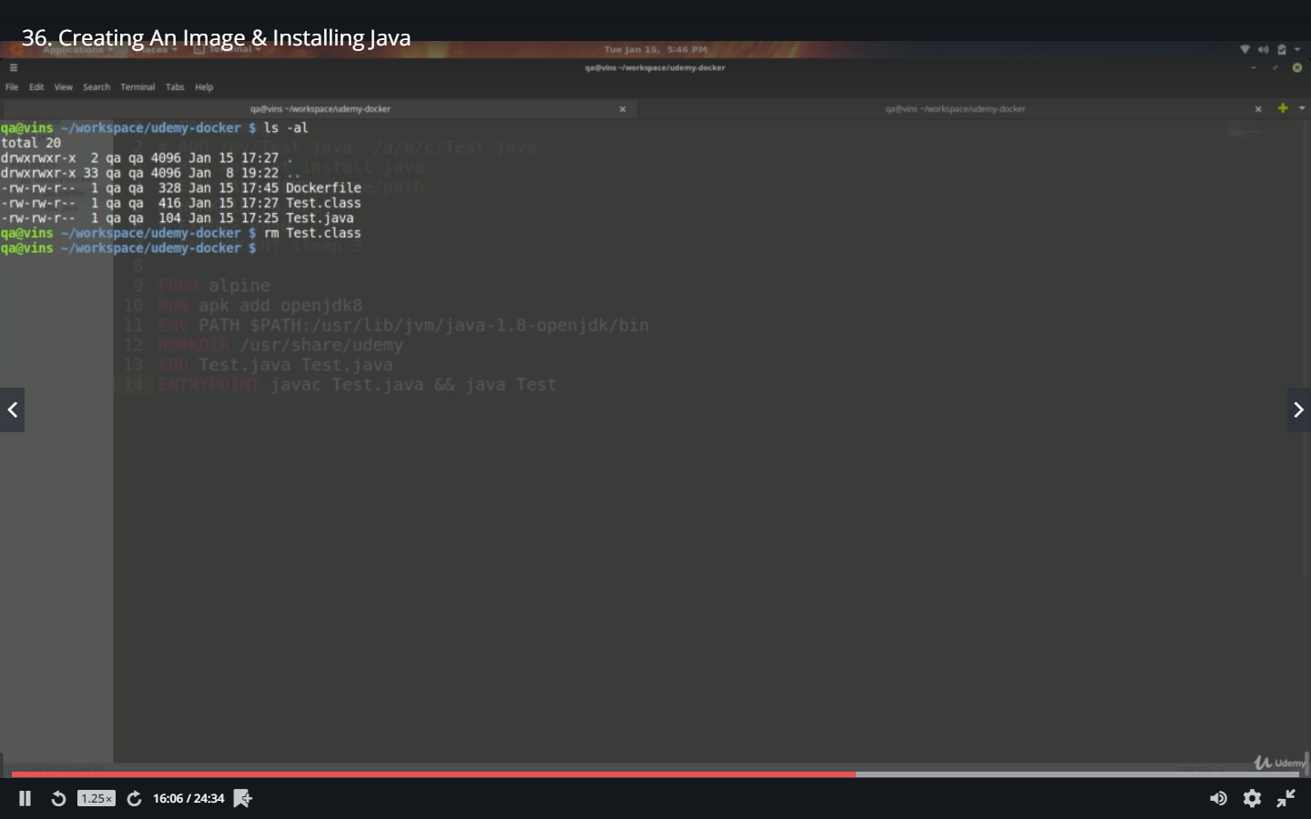

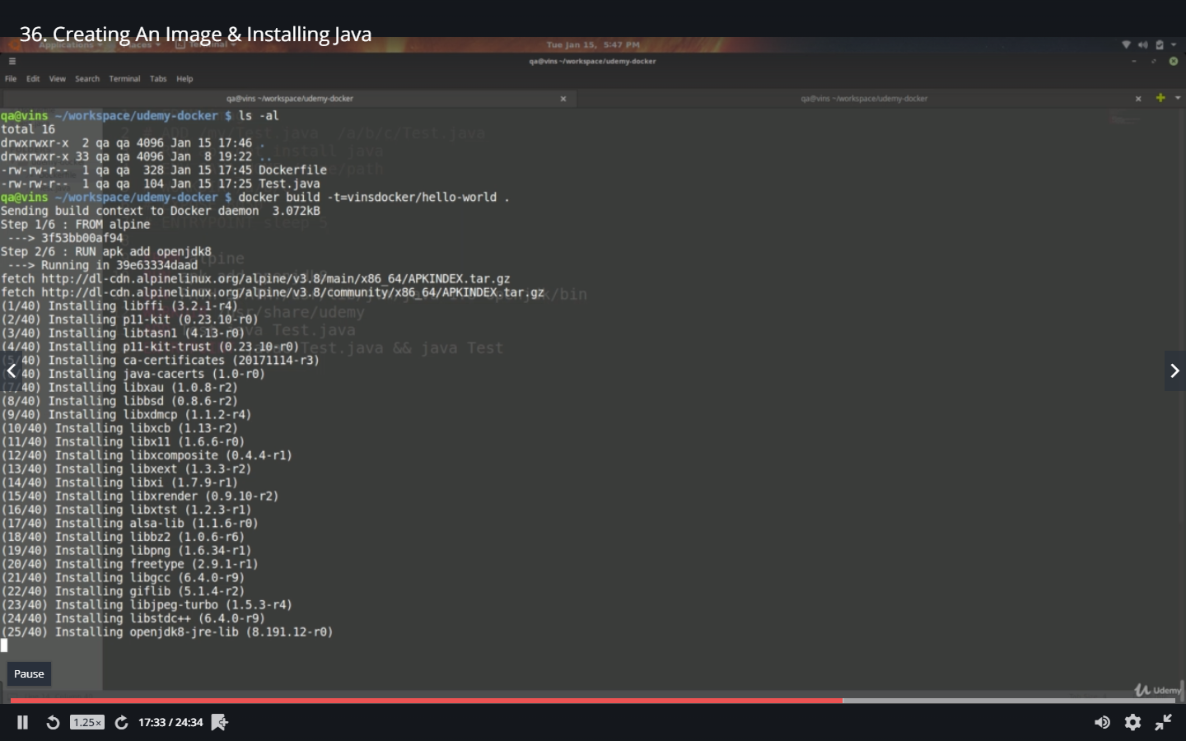

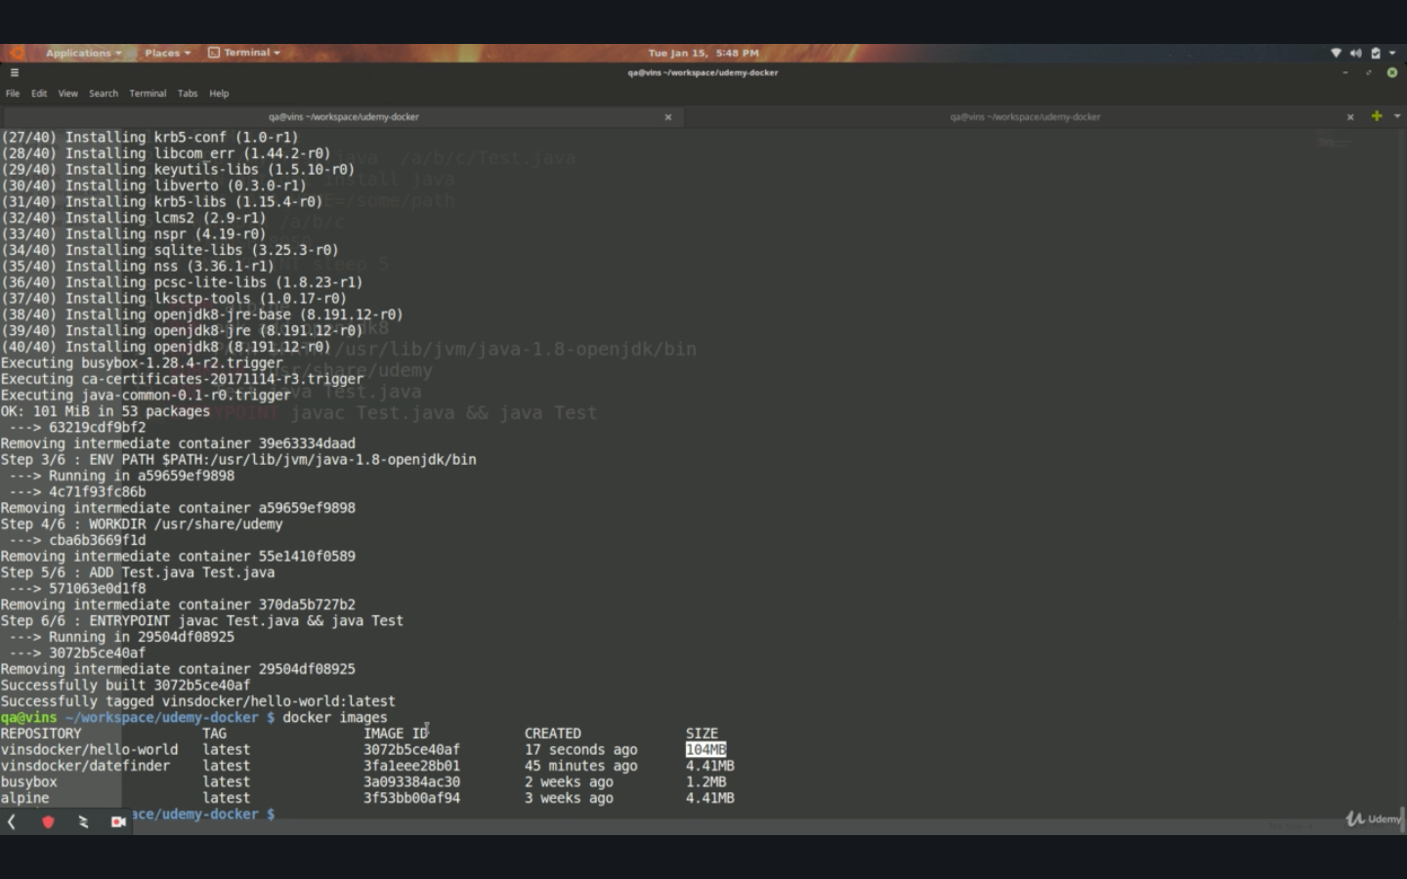

When we run the image file , the alpine shell command did not come as we have changed the entry point in our image . hence it compiled and ran the command and exited.

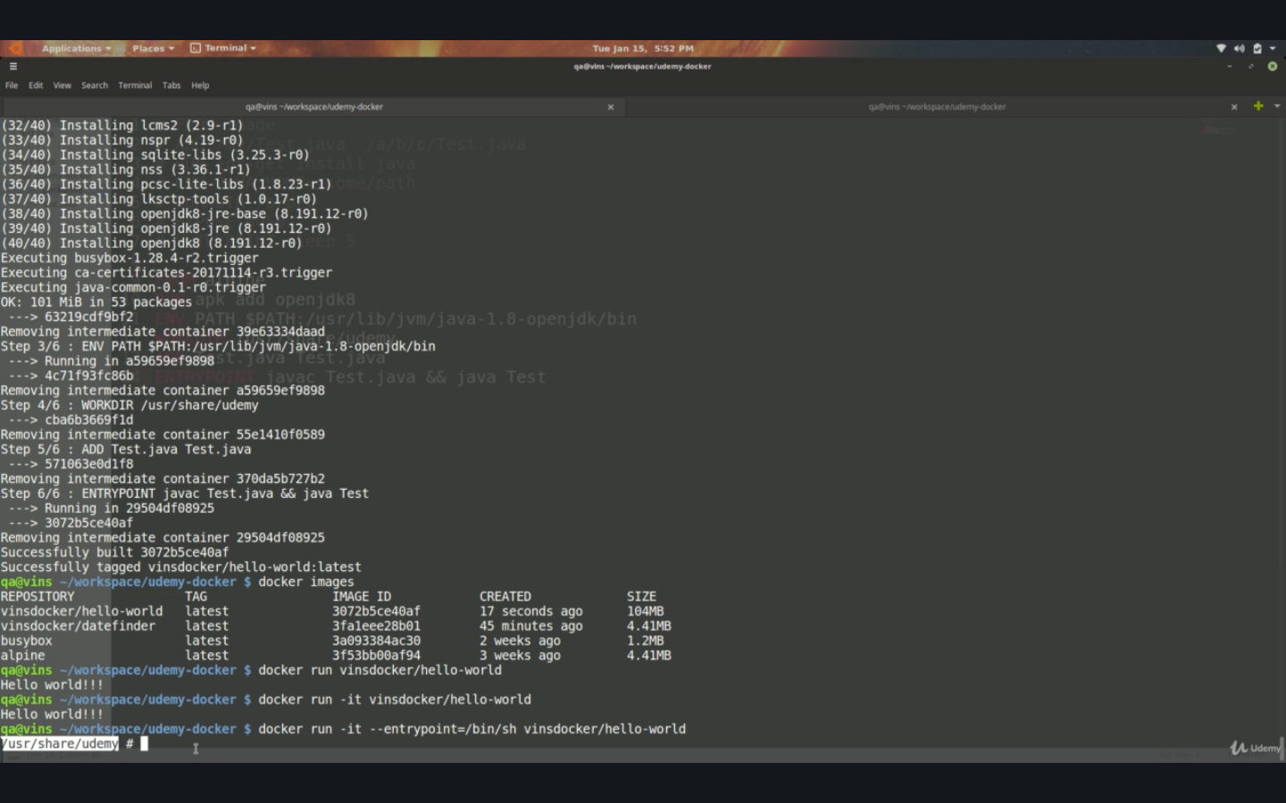

If you want to go to the shell and compile and execute on your own , override the entry point and run the image in interactive mode. All the other image properties would still be there and we are taken to the root directory and we can compile and execute the java code manually.

‘**docker run –it –entrypoint=/bin/sh subhashdocker/hello-world**

Alpine package Management - <https://wiki.alpinelinux.org/wiki/Alpine_Linux_package_management>

Alpine Packages - <https://pkgs.alpinelinux.org/packages>

Update the java file to take args from the bash

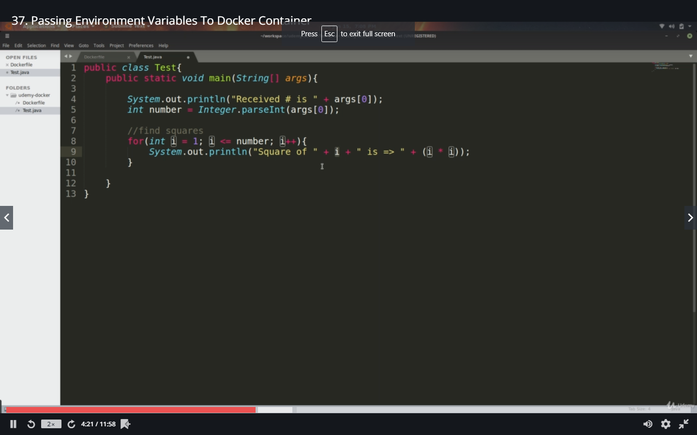

Hardcoded the argument in the docker file

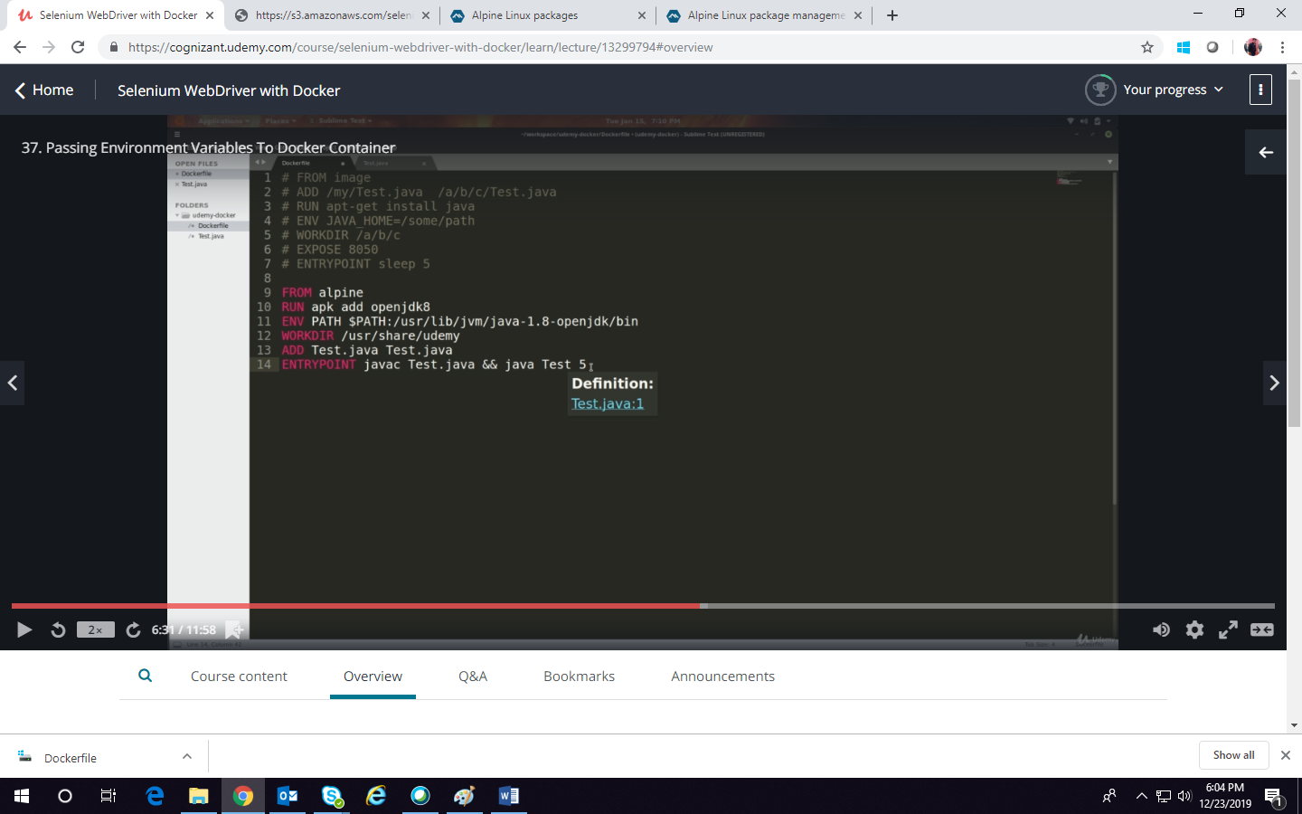

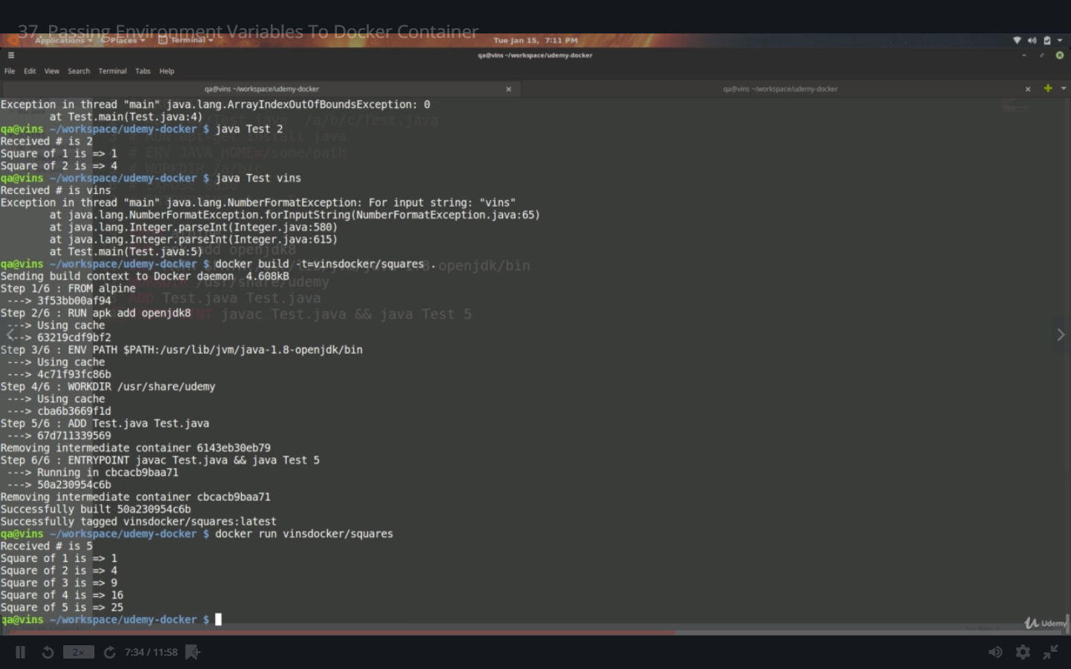

Create a variable in the docker file against the entry point and run the cmd

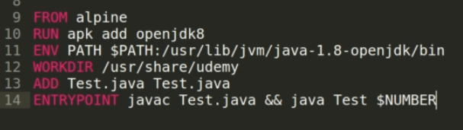



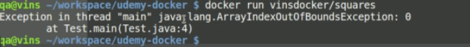

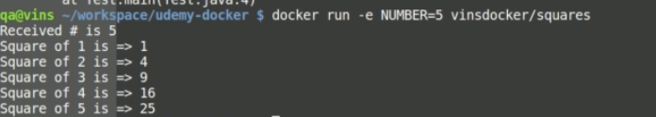

Pushing an image to docker Hub.

1.Create a docker hub account

2. Type docker and press enter , will list the docker commangs

3. docker login

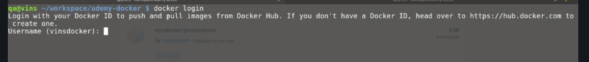

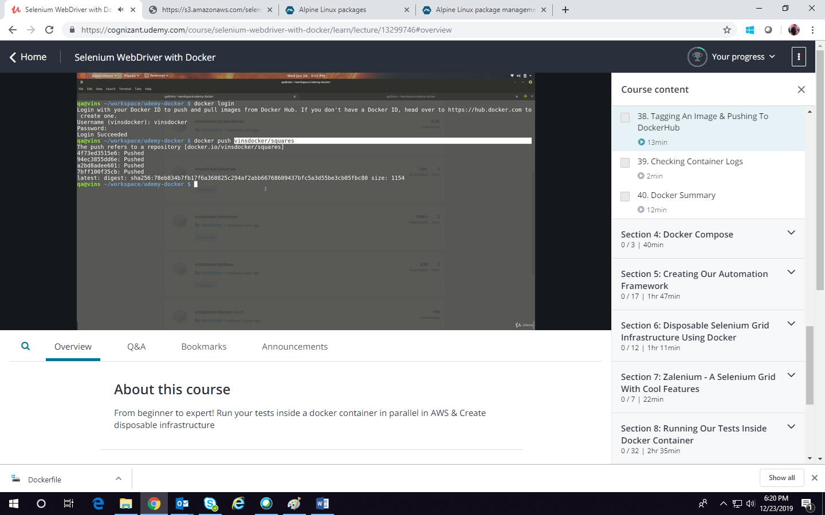

Docker push vinsdocker/squares:latest

Type latest if you want else it will added it to latest only. Now this will be pushed to the hub and now this can be used as a source and new image can be built.

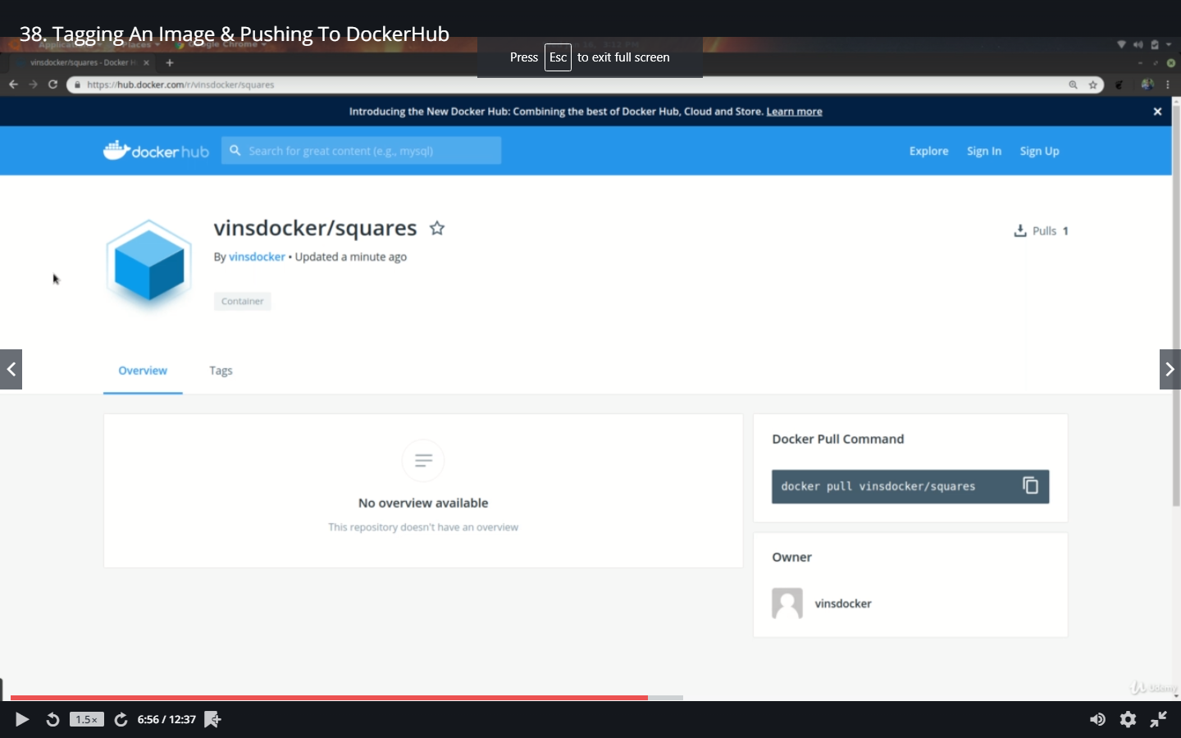

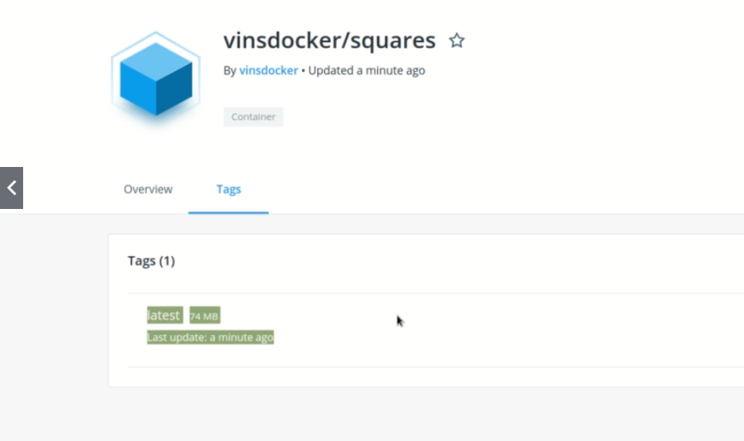

Suppose if we have updated the image file and want to push the updated image. Here we have biuilt it with latest and renamed the version and only the delta will be pushed

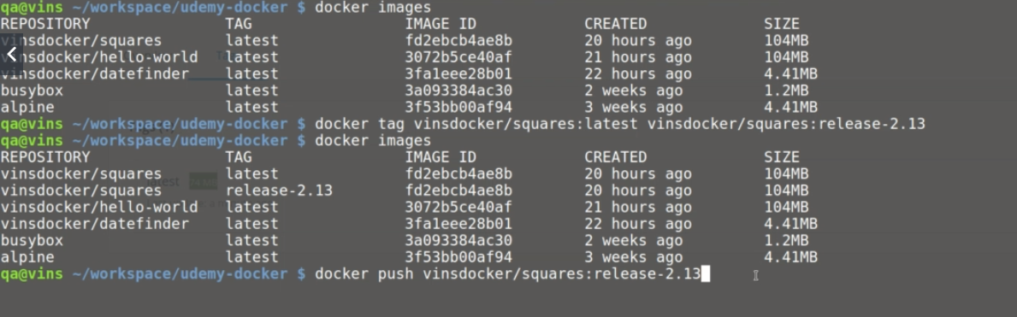

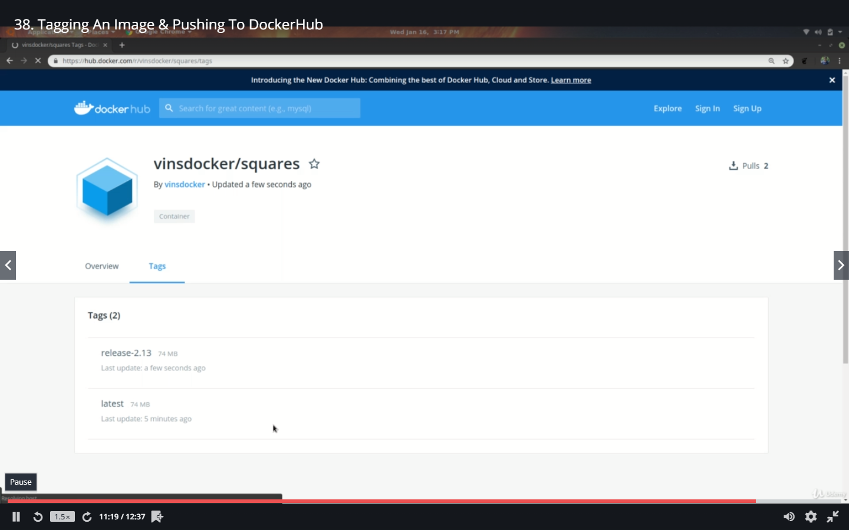

Docker logs even after the container has exited.

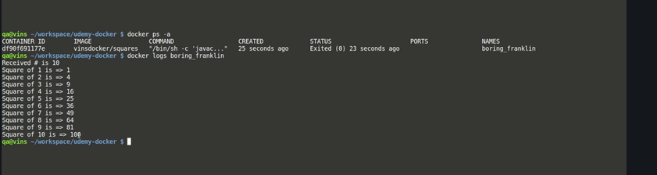

**Docker Compose**

Docker compose is another tool if not found install it

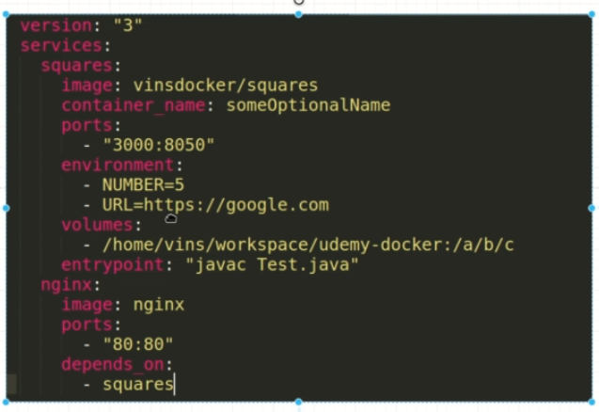

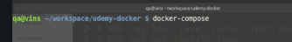

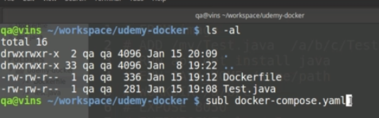

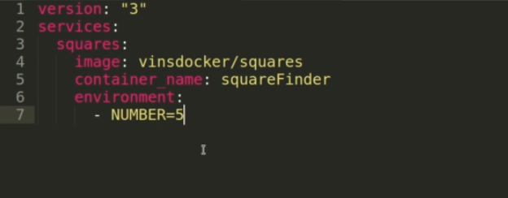

Here in the yaml file

Version – is the docker compose version

Services: List of Services

Squares: Some name that denotes the service

Image: image name

Container_name: any name that you want to give to the container

Environment:

* NUMBER=5

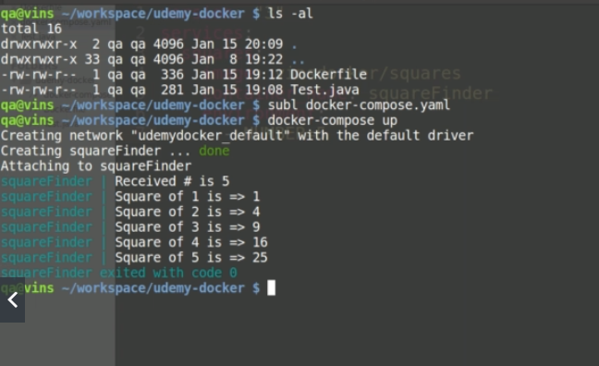

Once the docker-compose.yaml file is created . Just run the command **docker-compose up.** What it does is it will create a network by default and it will run the entry point of the image. But see the container name that we have given is prefixed with every output lines

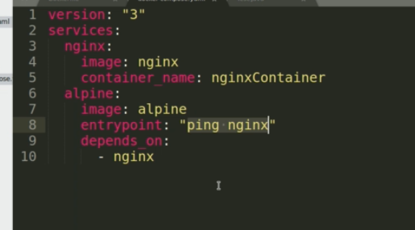

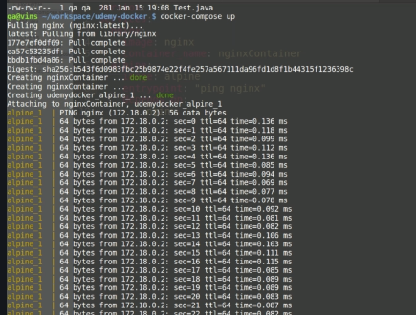

We can run the services behind. As Nginx is webserver and the Alpine is

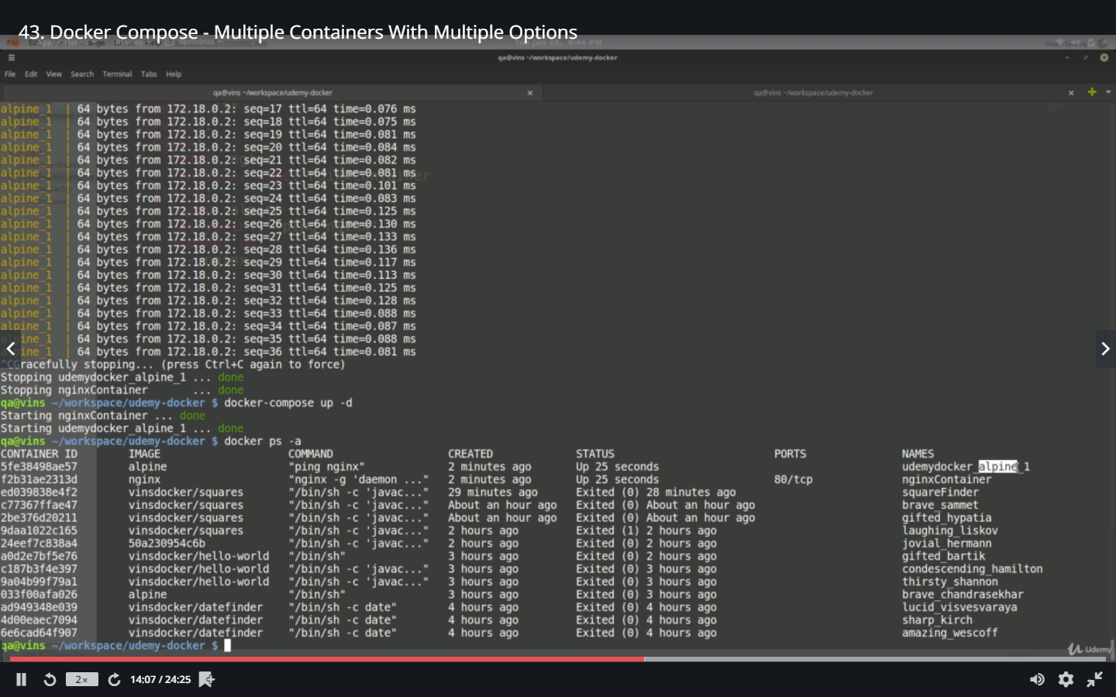

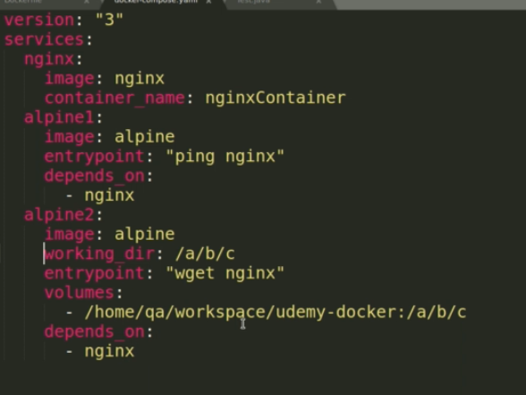

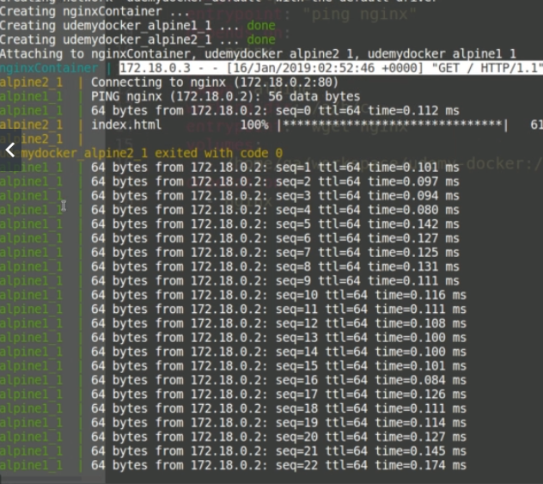

Selenium Grid – Docker

We will run these images in separate containers and run our scripts across these VMs.

Pull these images initially to reduce the download time.

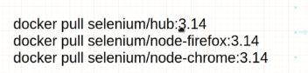

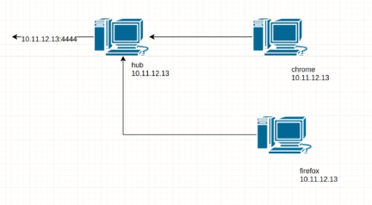

General Grid Structure without docker: The hub should be up and running. The clients will register with the hub using the ip address. The hub would be running on a port “4444” which can be used to view the hub in a console

Grid Structure with Docker:

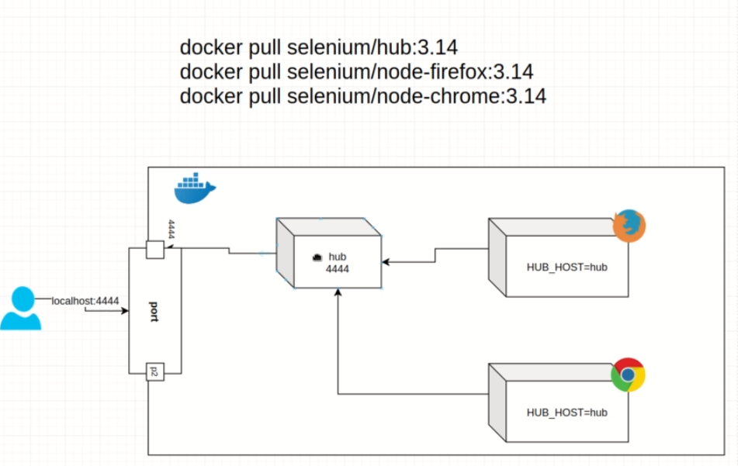

Here we are going to have the browser images in a container and set the environment variable **HUB_HOST** pointing to hub which would register the nodes to the hub. When we specify the services in the **docker-compose** all the services would be connected to a network by default. We need to then map the port of the hub (service) with the client machine (local host) to get the output in a console

Check for the images and the containers

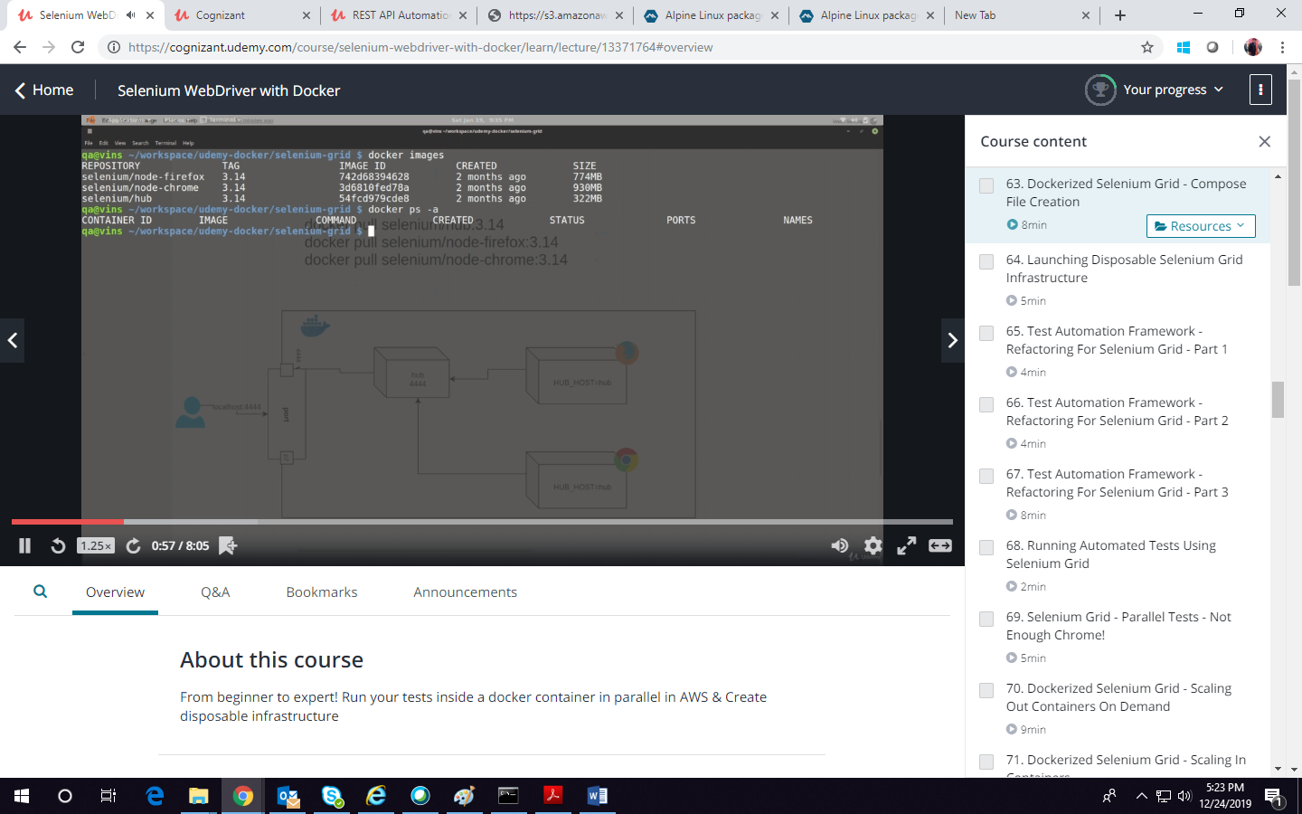

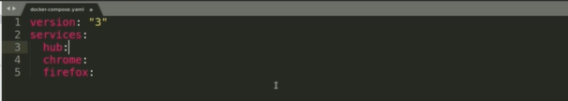

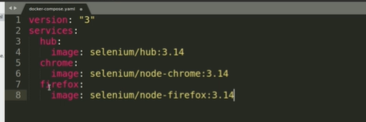

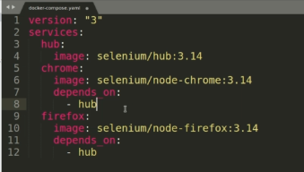

Chrome and firefox depends on hub and should wait until the hub is up and running

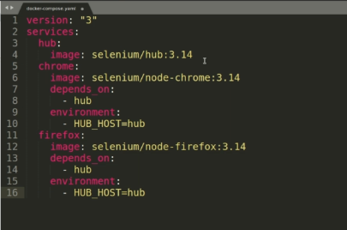

Specify the HUB_HOST=Hub to enable the chrome to register with the HUB

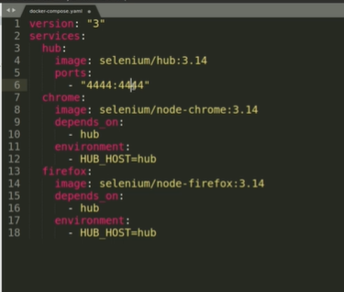

A service can depend on any no of services. Similarly a hub can be mapped to diff ports

The variables **–** here denotes there could be many no of variable mapping



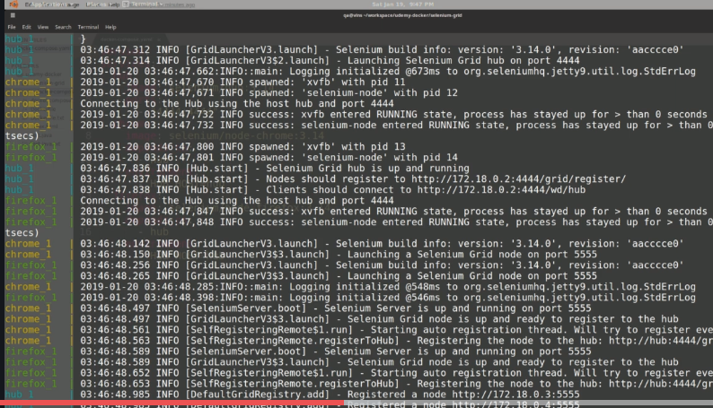

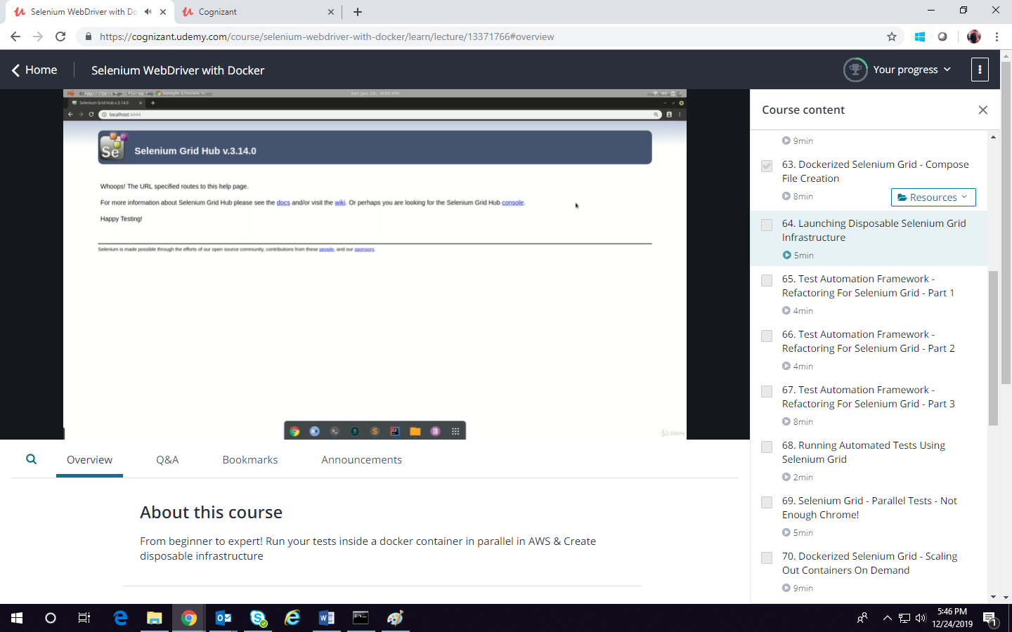

Click console

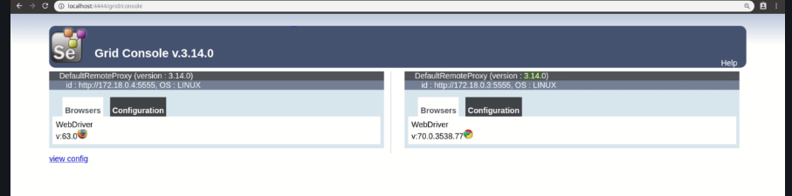

**‘docker compose down**

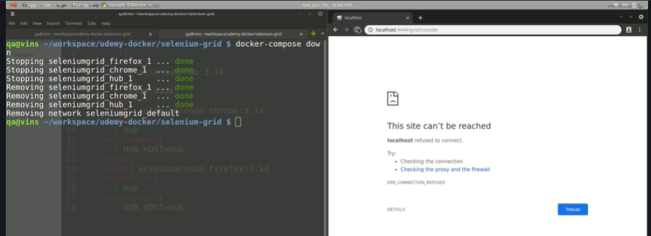

Stops the service. This is a disposable selenium grid.

In the below example we have a base class which initialize the driver and quit the driver

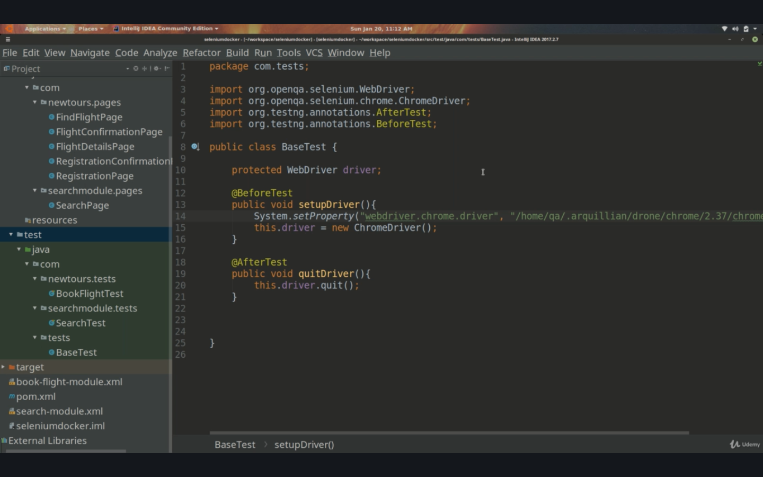

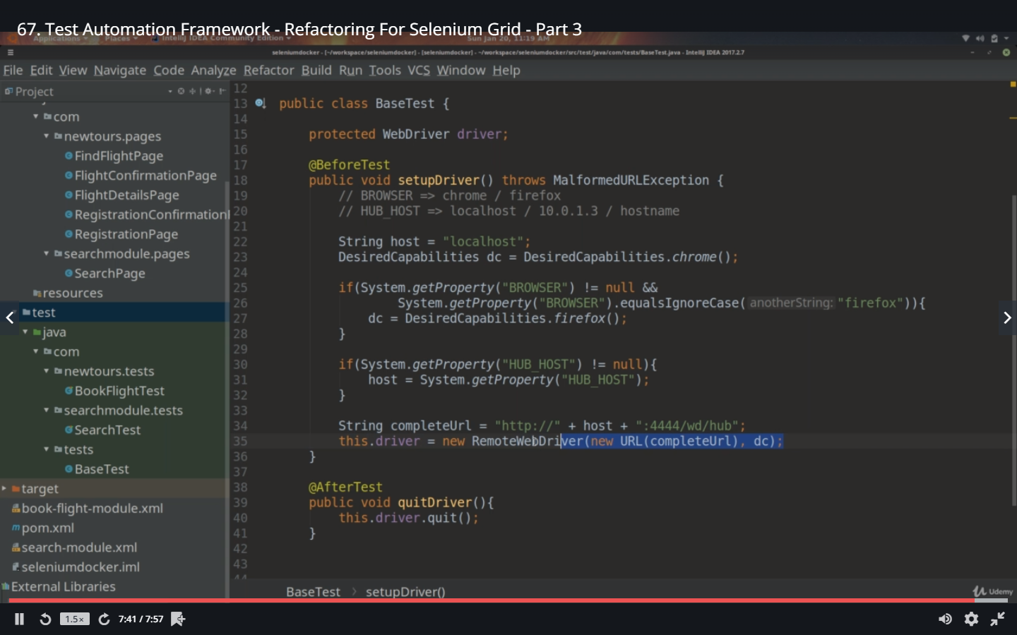

Now here we are specifying the driver as remote webdriver. We are giving the host as local host and the port as 4444 which is port mapped to the hub . This is complete URL to the remote machine. And the desired capability is set to dc by default it’s chrome. If you run your tests now, it would run the script in the chrome container

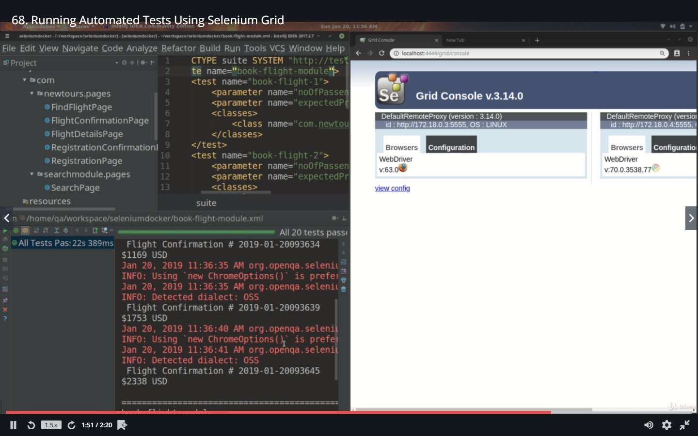

Here we are running our tests with four different parameters from the xml file

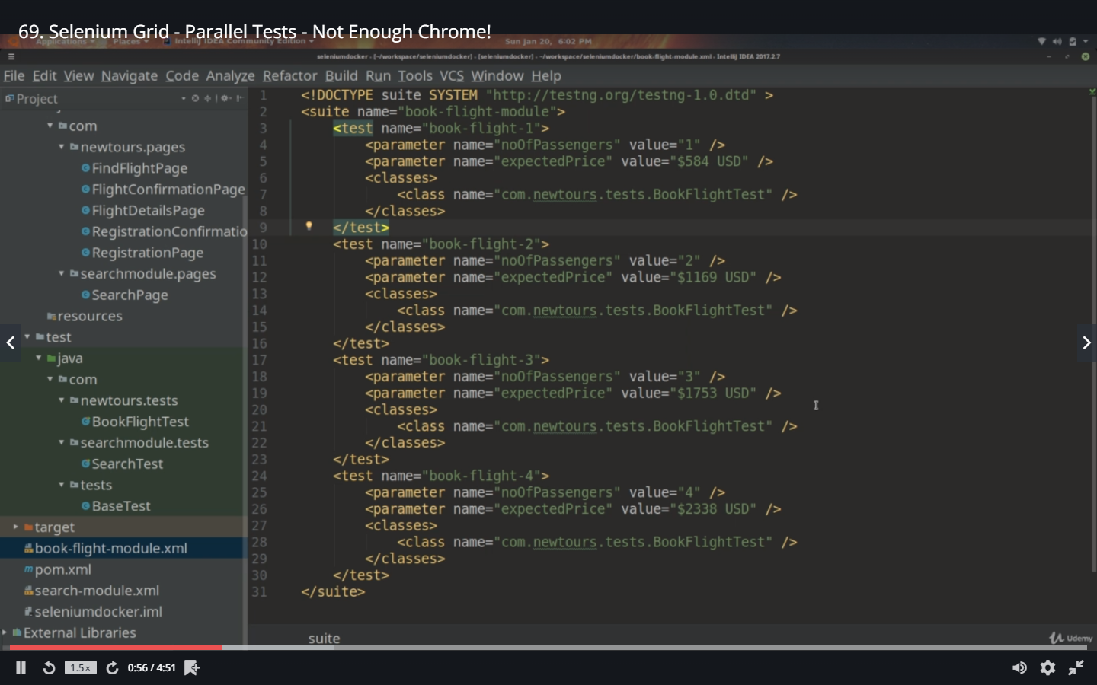

Marking the tests to run in parallel

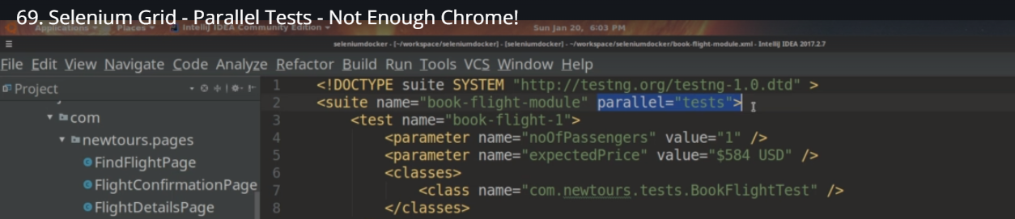

4 threads are created whereas we have only 1 chrome and the others are put into the queue.

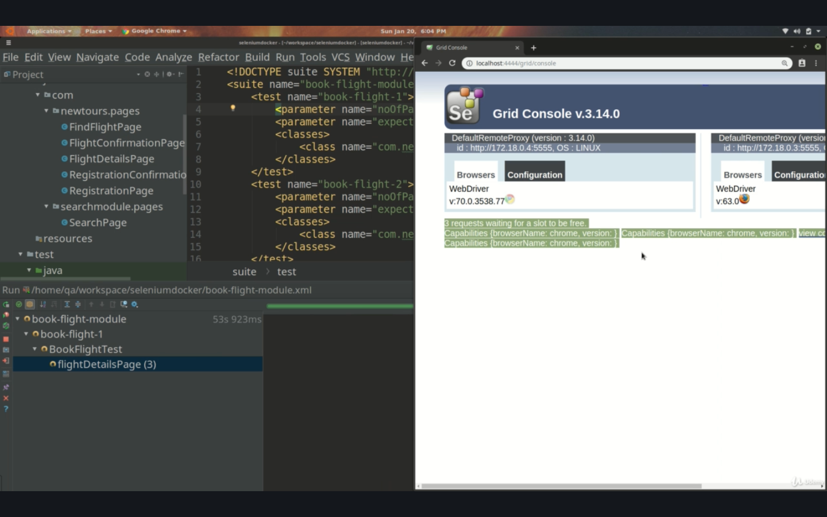

‘**docker-compose up –d**

This command will just display the services and running and says its up to date. It does not create new grid and does no harm

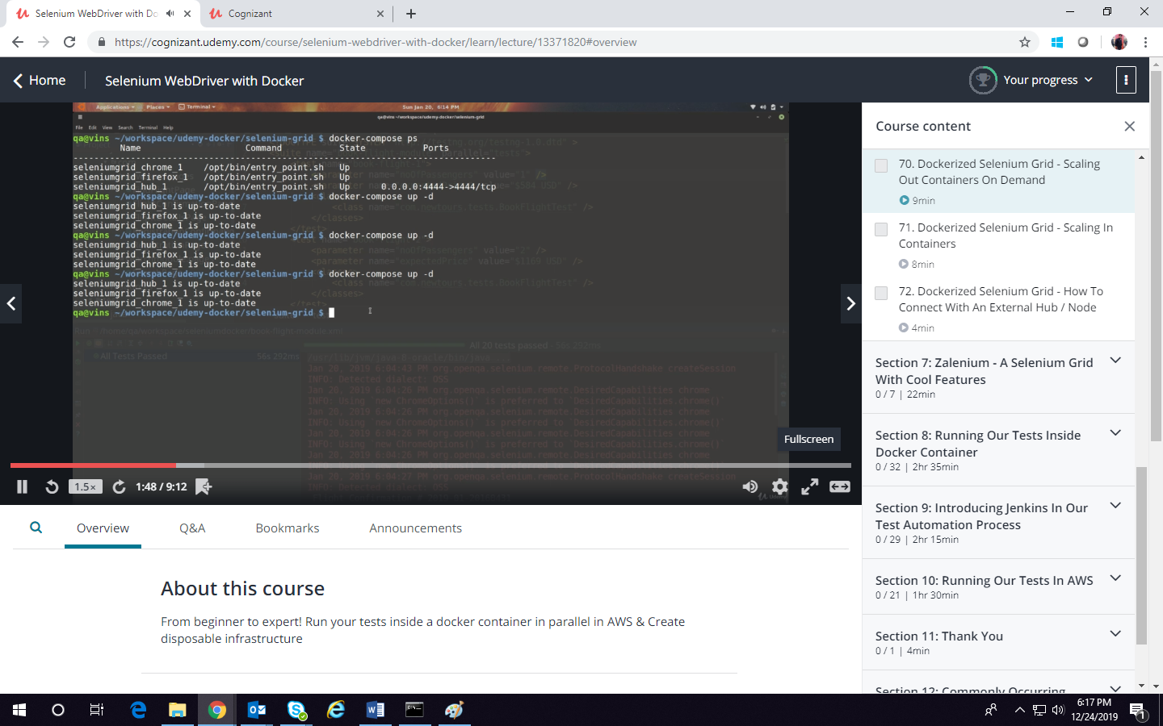

If we want to scale the no of services. Eg Chrome services to run in 4 containers

‘**docker-compose –d - -scale chrome=4**

This first checks “-d” the services running and confirm if everything is as specified in the compose.

It checks firefox and hub are upto date and chrome is done as per the scaling and creates the 4 containers

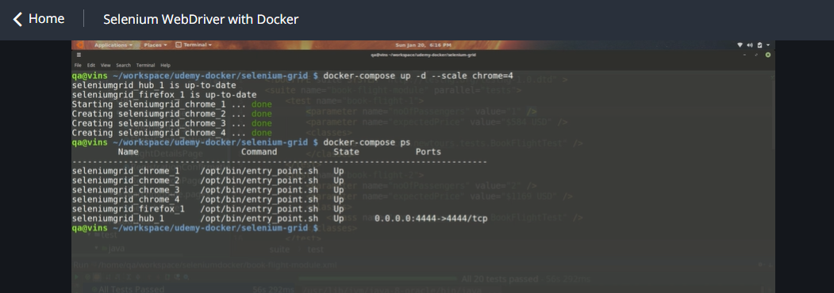

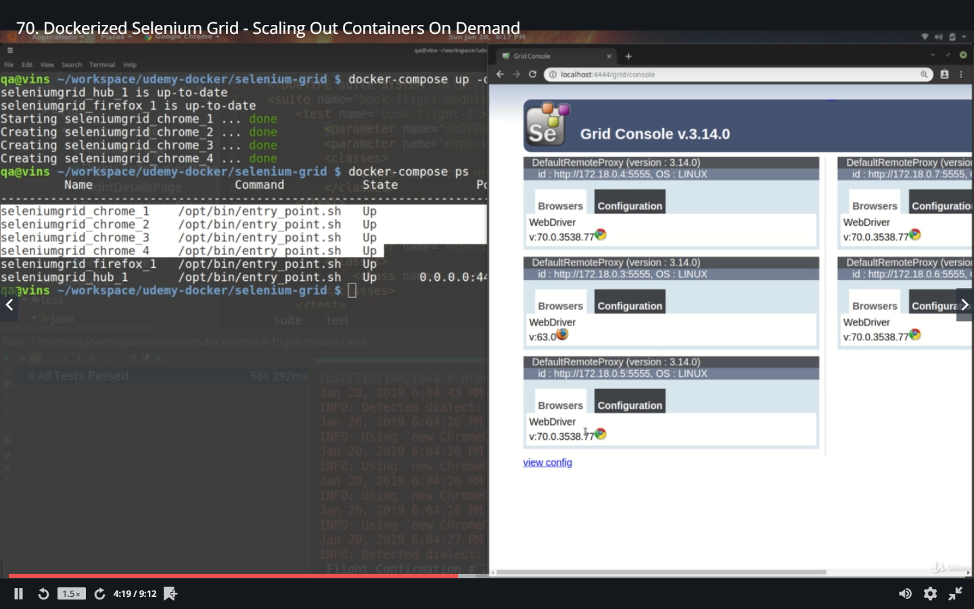

When we have 4 chromes it reflects fast. When we scale down from 4 to 3 and refresh the local host it still shows 4. When the nodes registers to the hub they make a connection when they scale in (disconnect) they do not let the hub know they are getting disconnected and the hub does not know that they are disconnected.

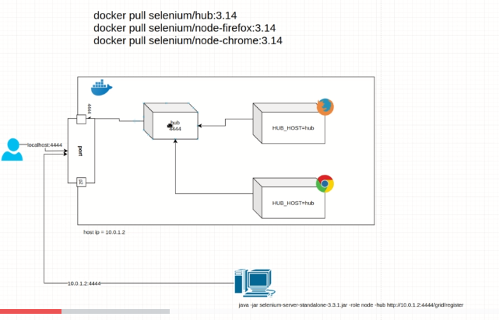

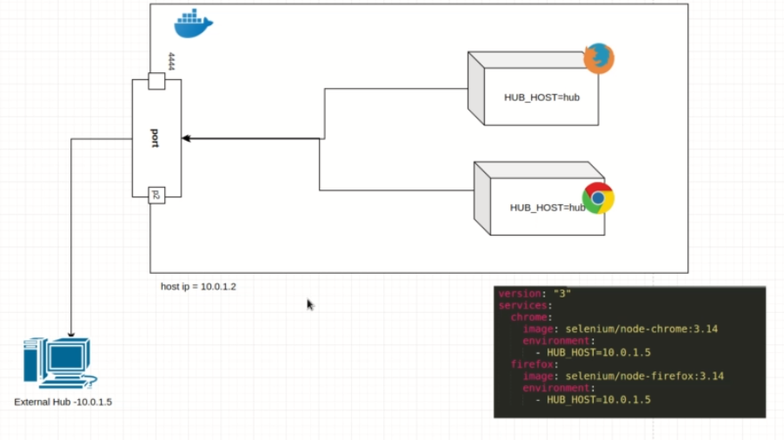s